BED Documentation (p2112646)

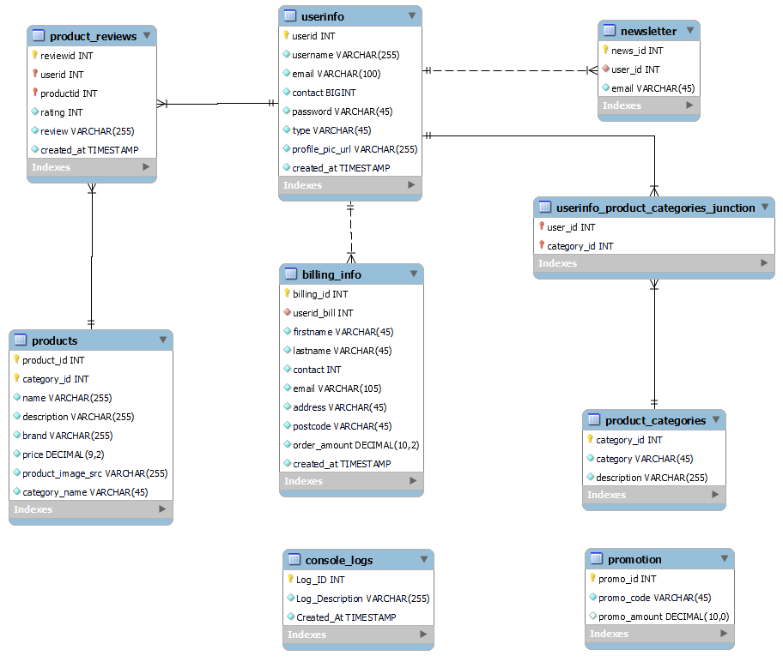

Add Product with Image

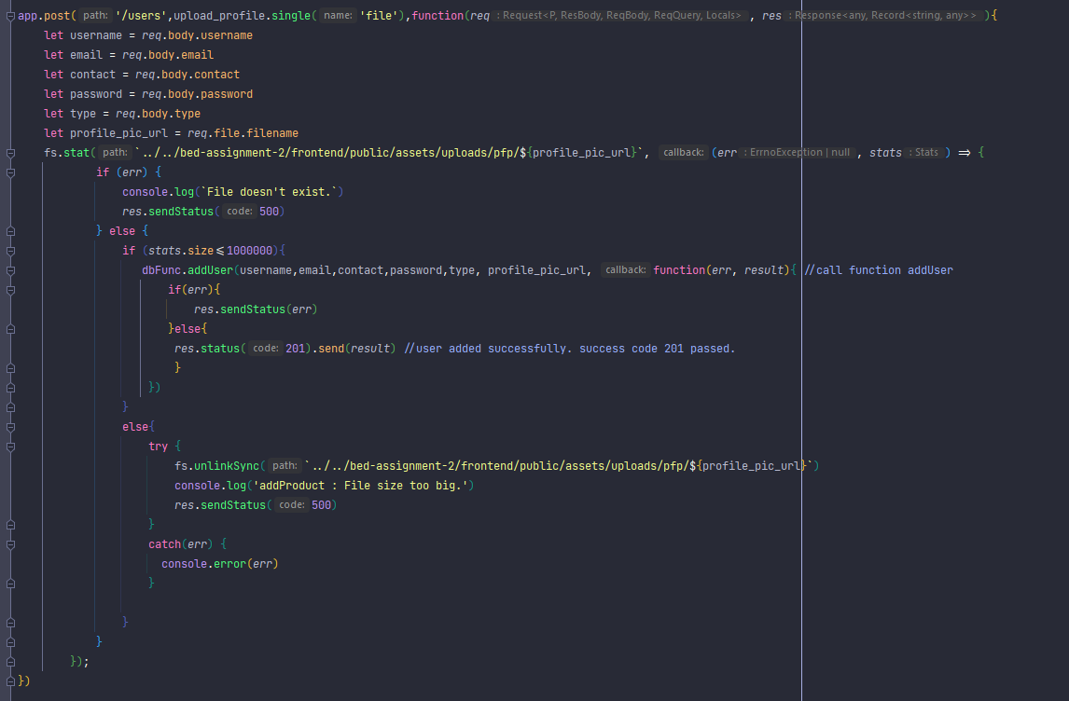

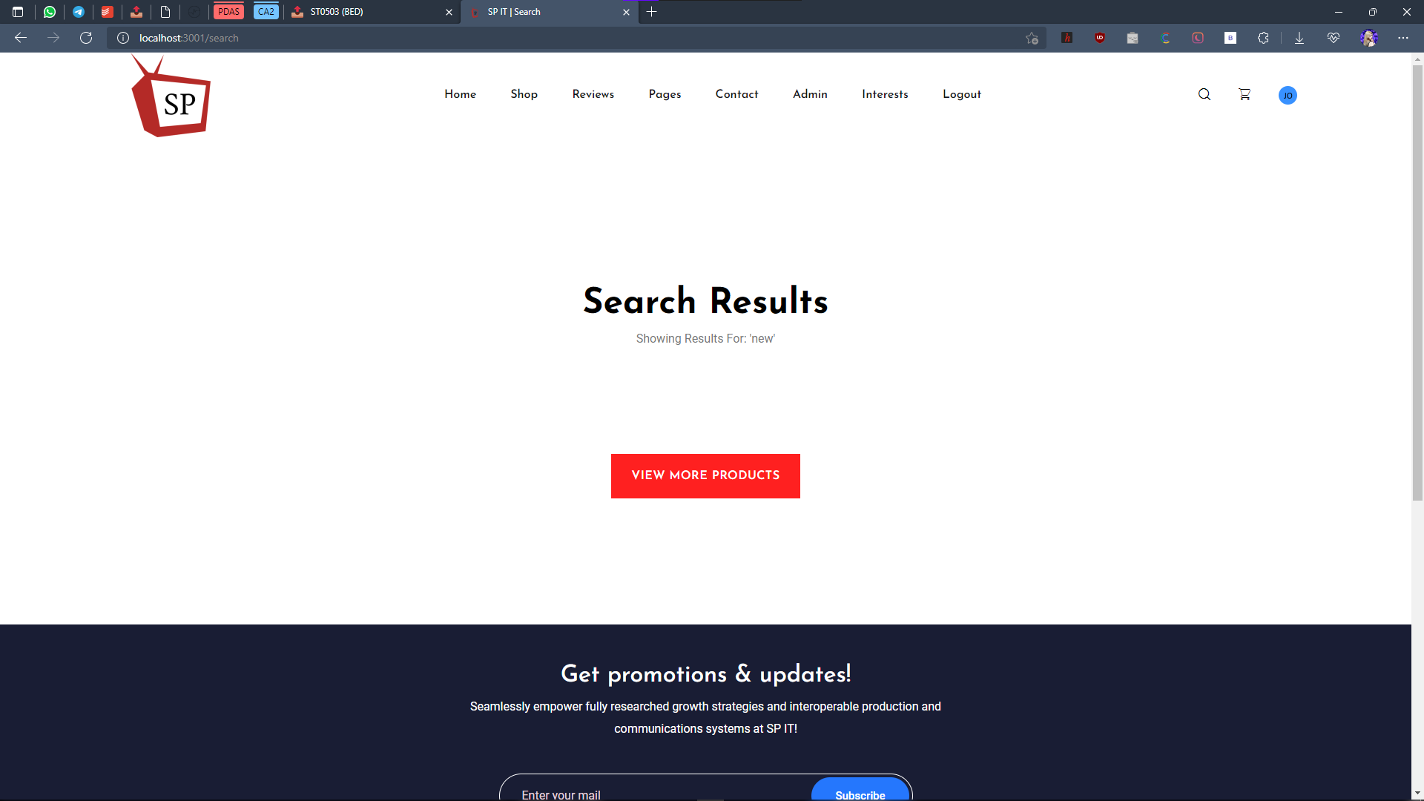

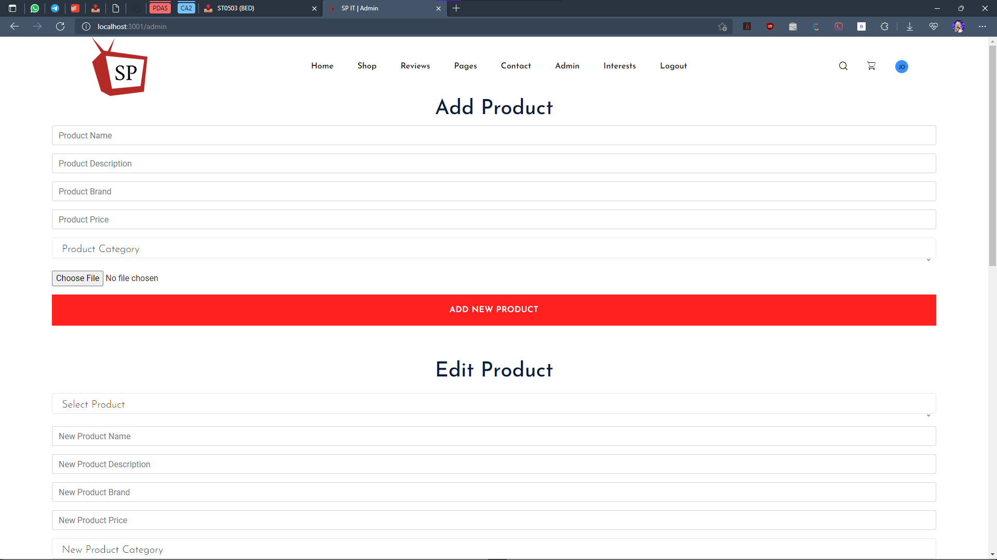

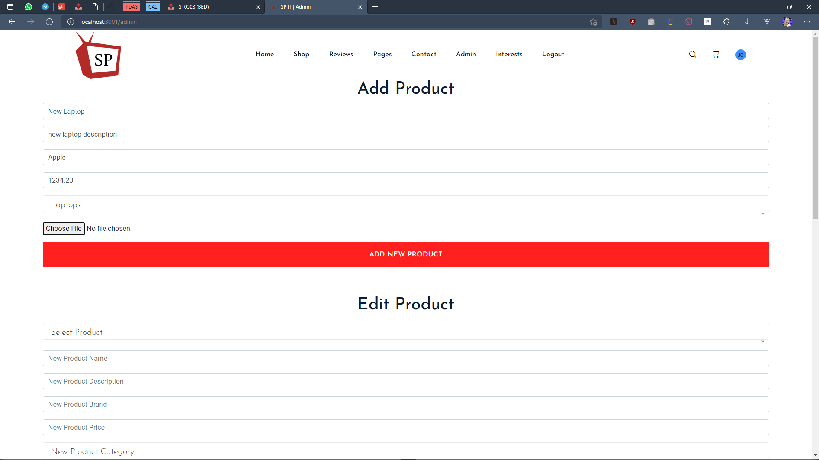

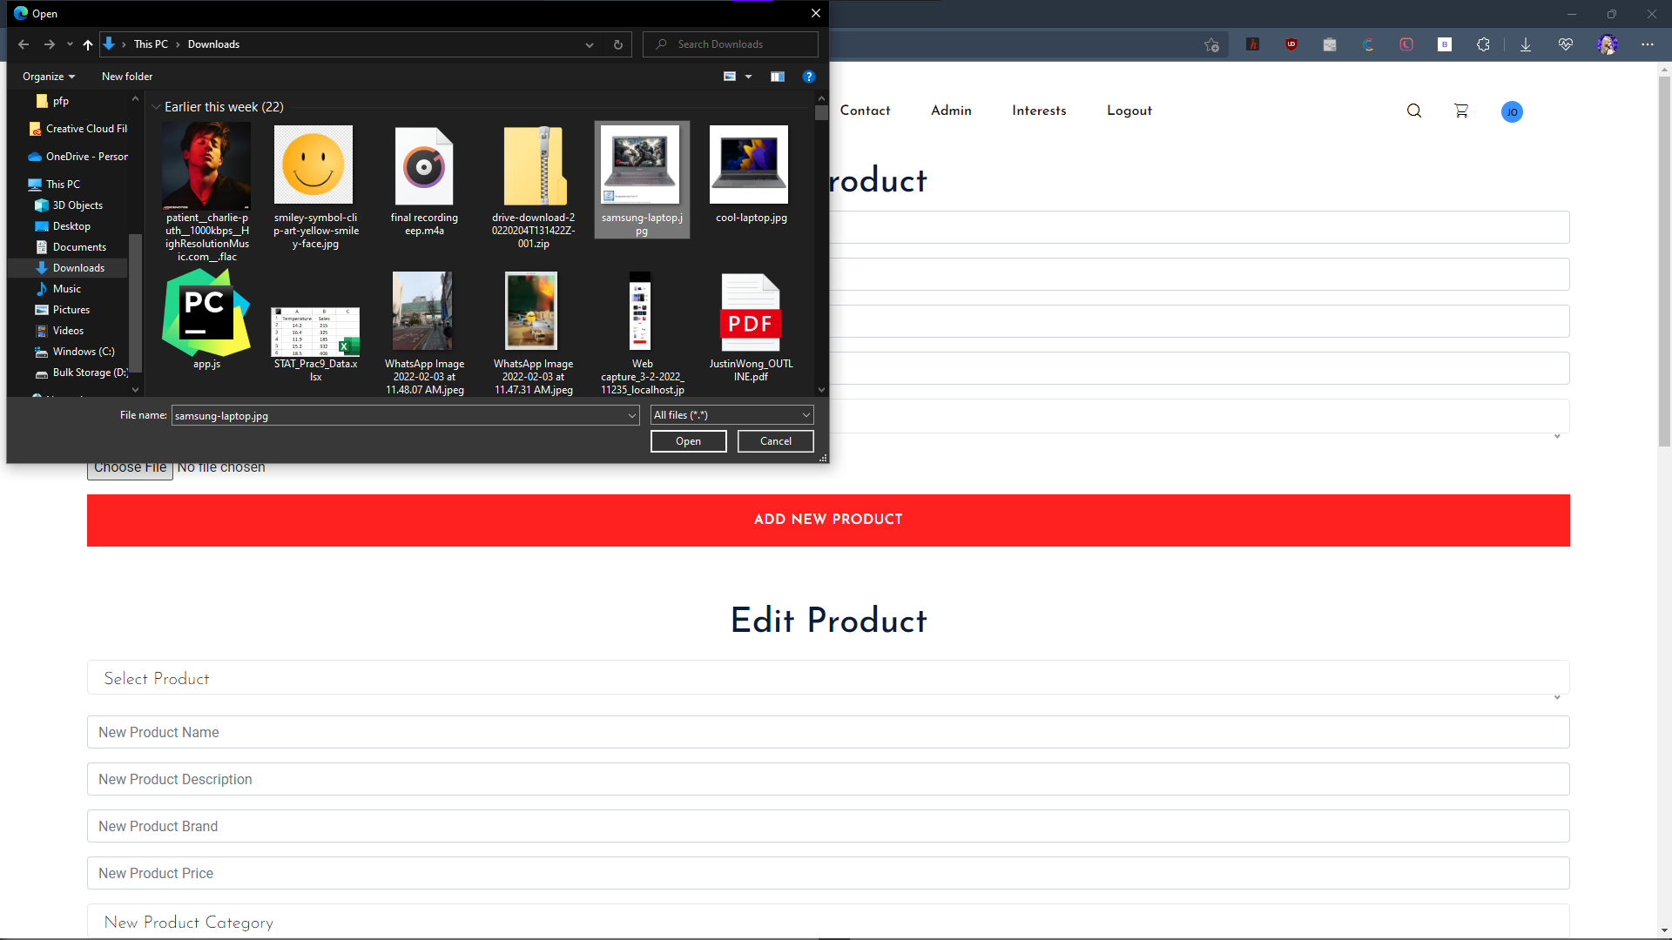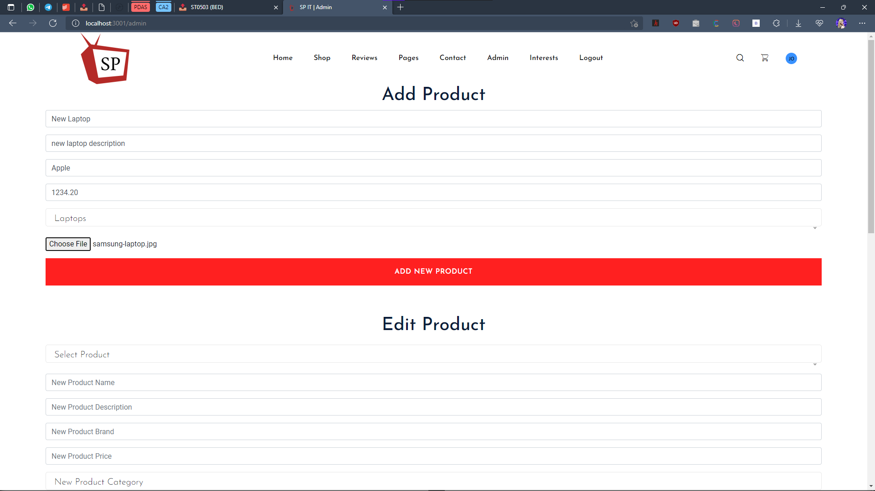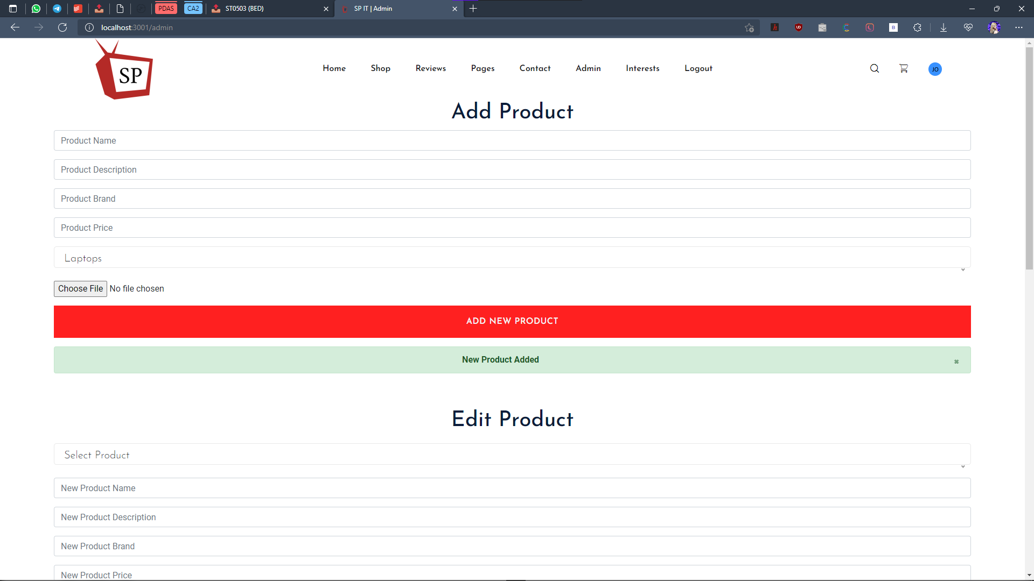

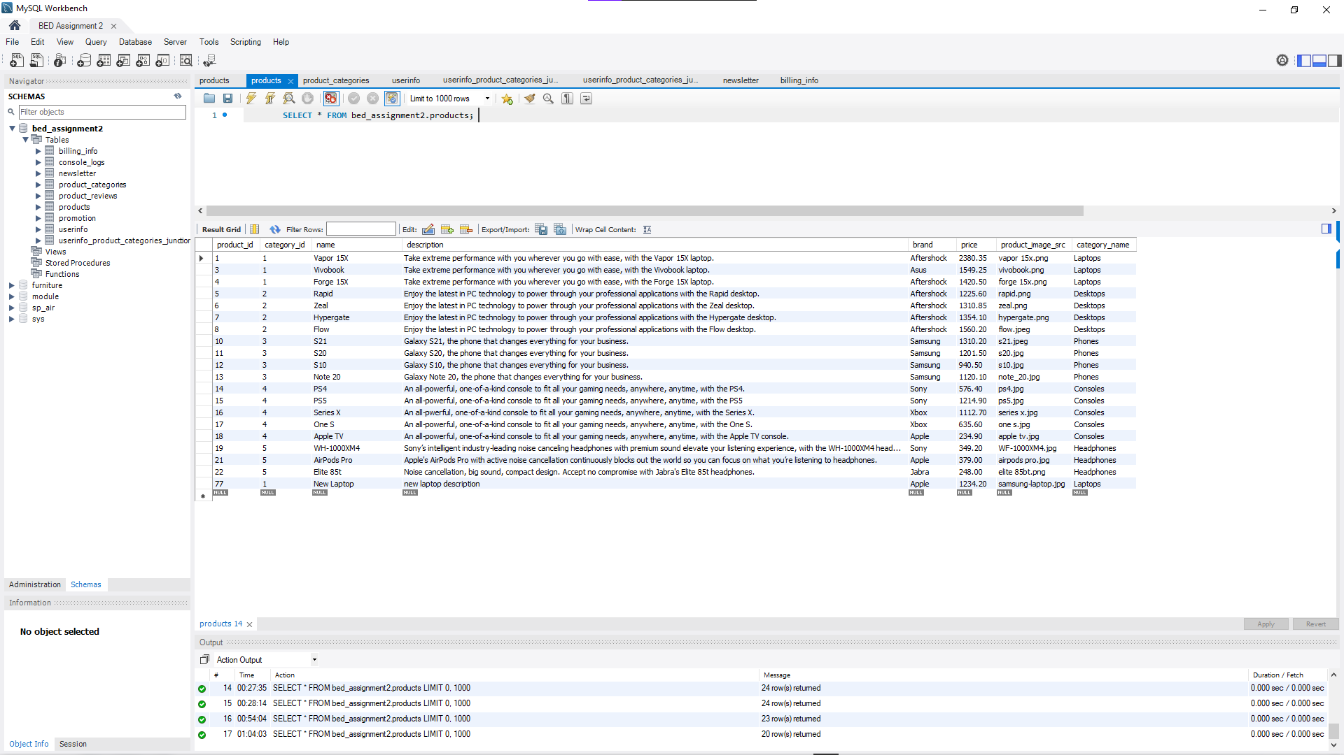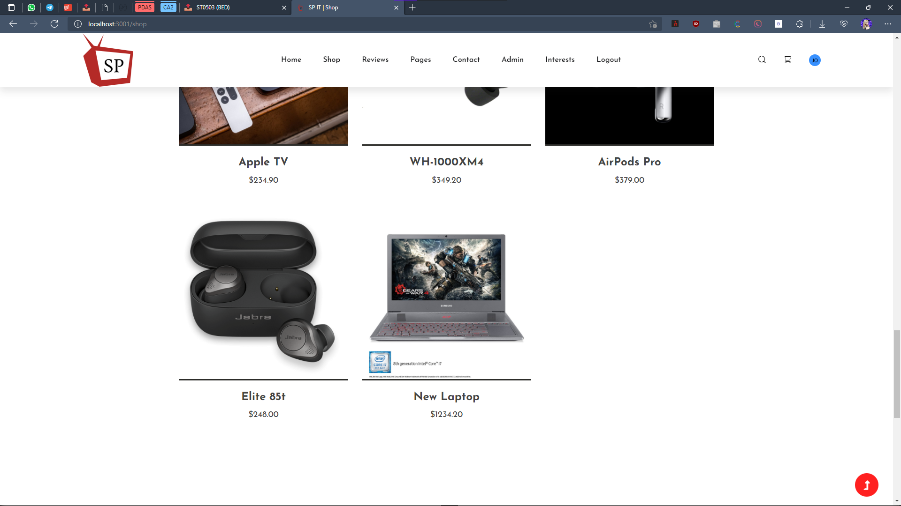

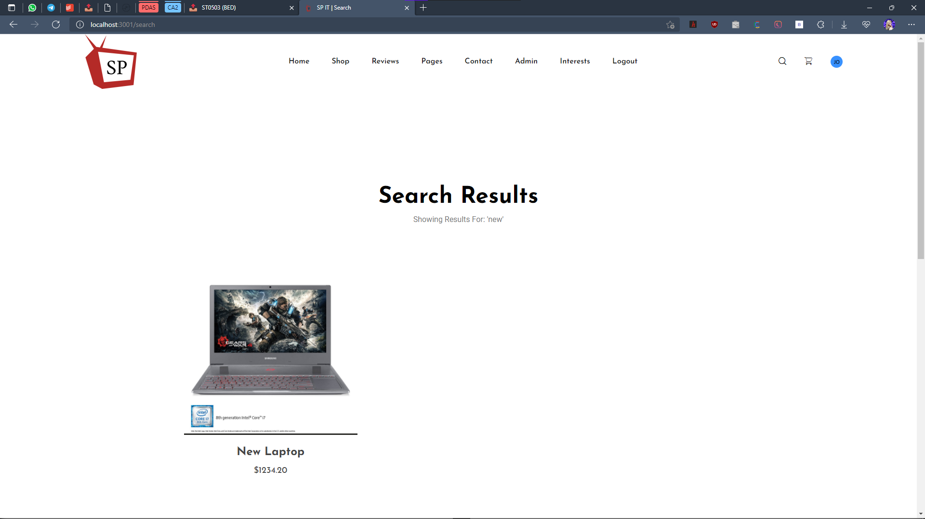

Edit Product Details

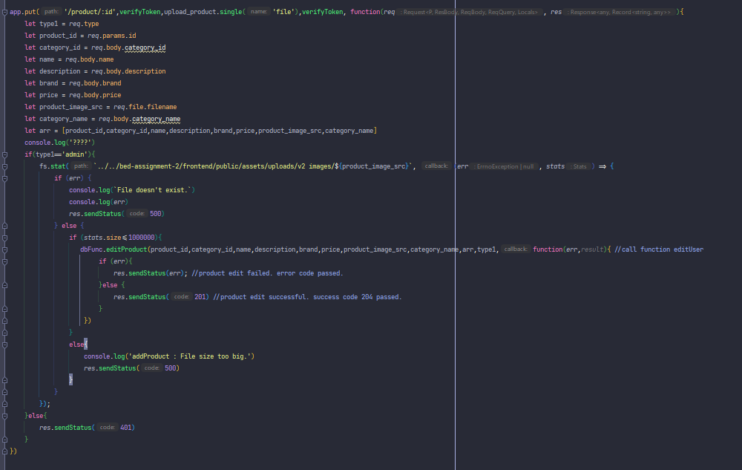

editProduct : function**(***id*, *category_id*,*name*,*description*,*brand*,*price*,*product_image_src*,*category_name*,*arr*,*type1*,*callback***){** let conn = db.getConnection**()**;  
 conn.connect**(**function**(***err***){** if **(***err***){** log**(**'\neditUser : Error. Could not connect to SQL Server.\n'+*err***)** //check for sql connection  
 return *callback***(**500,null**)  
 }** else**{** if **(***type1*=='admin'**){** if**(**isNaN**(***category_id***)){** log**(**'\neditUser : Bad Request. Input received mismatches required datatype.'**)** return *callback***(**400,null**)  
 }** if**(***type1*=='customer'|| *type1*=='admin'|| type==''**){** let sqlquery = 'SELECT * FROM products WHERE product_id = *?*'  
 conn.query**(**sqlquery, **[***id***]**, function **(***err*,*result***){** if **(***err***){** log**(**'\neditUser : Internal Server Error.\n'+*err***)** //internal sql error. error code 500 passed  
 return *callback***(**500,null**)**;  
 **}** else**{** if **(***result***[**0**]** === undefined**){** log**(**`editUser : Connected to SQL Server: Product $**{***id***}** not found.`**)**; //404 error code passed. user not found  
 return *callback***(**404,null**)  
 }** else**{** if**(((***result***[**0**]**.name**)**==*name***)){** //check for duplicate information  
 log**(**'\neditUser : Duplicate Entry. The new name provided already exists.'**)**; //422 error code. duplicate entries found  
 return *callback***(**422,null**)  
 }** else**{** let sqlquery = 'SELECT * FROM products WHERE product_id= *?*'  
 conn.query**(**sqlquery,*id*,function**(***err*,*result***){** if **(***err***){** log**(**'\neditUser : Internal Server Error\n'+*err***)** //internal sql error. error code 500 passed  
 return *callback***(**500, null**)  
 }**else**{** let values = Object.values**(***result***[**0**])** let dump = values.shift**()** for**(**let i = 0; i<*arr*.length; i++**){** if**(***arr***[**i**]**==''**){** *arr***[**i**]** = values**[**i+1**]  
 }** else if**(***arr***[**i**]**==values**[**i+1**]){** return *callback***(**422,null**)  
 }  
 }** console.log**(**'\nFull Product Info =>\n',*arr***)** let sqlquery = `UPDATE products SET category_id=*?*,name=*?*,description=*?*,brand=*?*,price=*?*,product_image_src=*?*,category_name=*?* WHERE product_id=*?*` //update user info  
 conn.query**(**sqlquery, **[***arr***[**1**]**,*arr***[**2**]**,*arr***[**3**]**,*arr***[**4**]**,*arr***[**5**]**,*arr***[**6**]**,*arr***[**7**]**,*arr***[**0**]]**,function**(***err*,*result***){** conn.end**()**;  
 if **(***err***) {** if **(***err*.errno === 1062**) {** //check if duplicate error  
 log**(**'\neditUser : Duplicate Entry. The new username OR new email provided already exists.\n'+*err***)**; //duplicate error found. 422 error code passed  
 return *callback***(**422, null**)  
 }** else **{** console.log**(**'\neditUser : Internal Server Error\n'+*err***)** //internal sql error. error code 500 passed  
 return *callback***(**500, null**)  
 }  
 }** else**{** log**(**`\neditUser : Edited Product ID: $**{***id***}**`**)** return *callback***(**null,201**)  
 }  
 })  
 }  
 })  
 }  
 }  
 }  
 })  
 }**else**{** log**(**'\neditUser : Bad Request. Input received mismatches required datatype.'**)** return *callback***(**400,null**)  
 }  
 }** else**{** return *callback***(**401,null**)  
 }  
  
 }  
 })  
}**

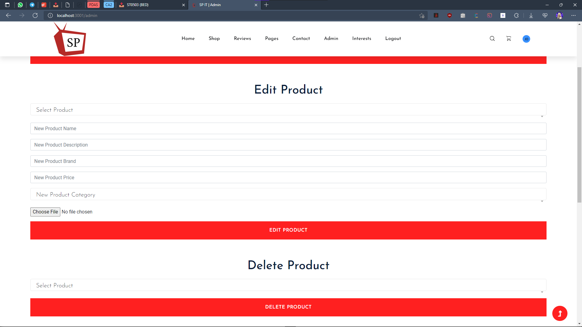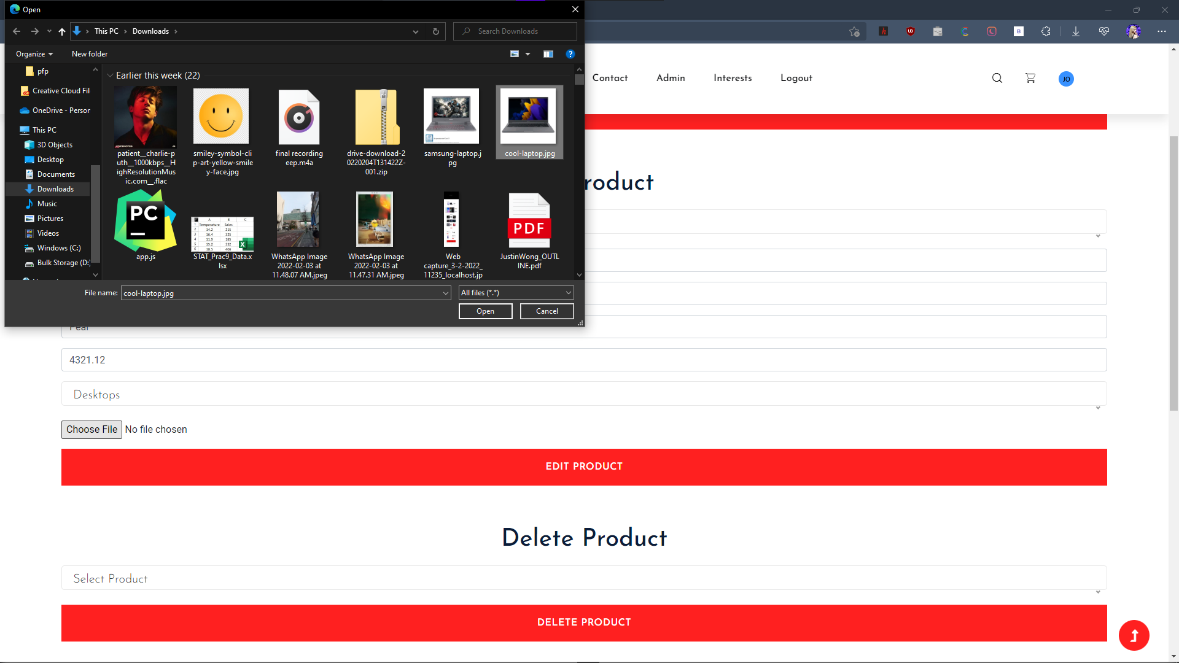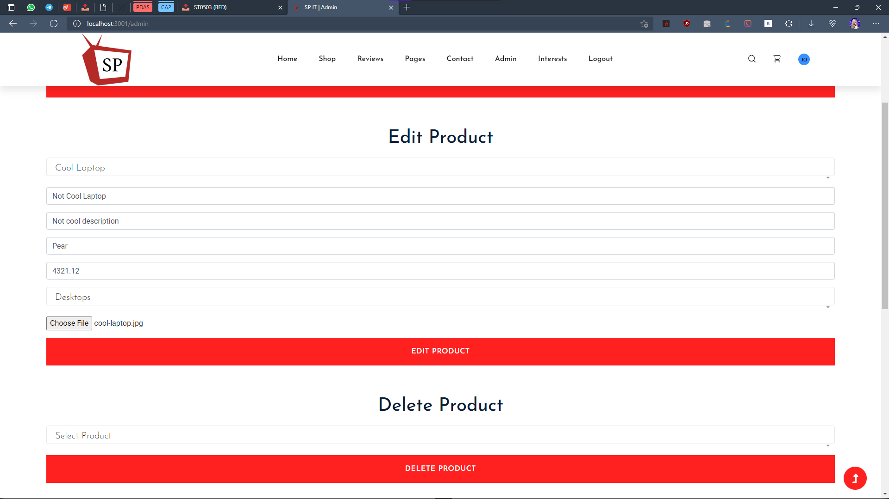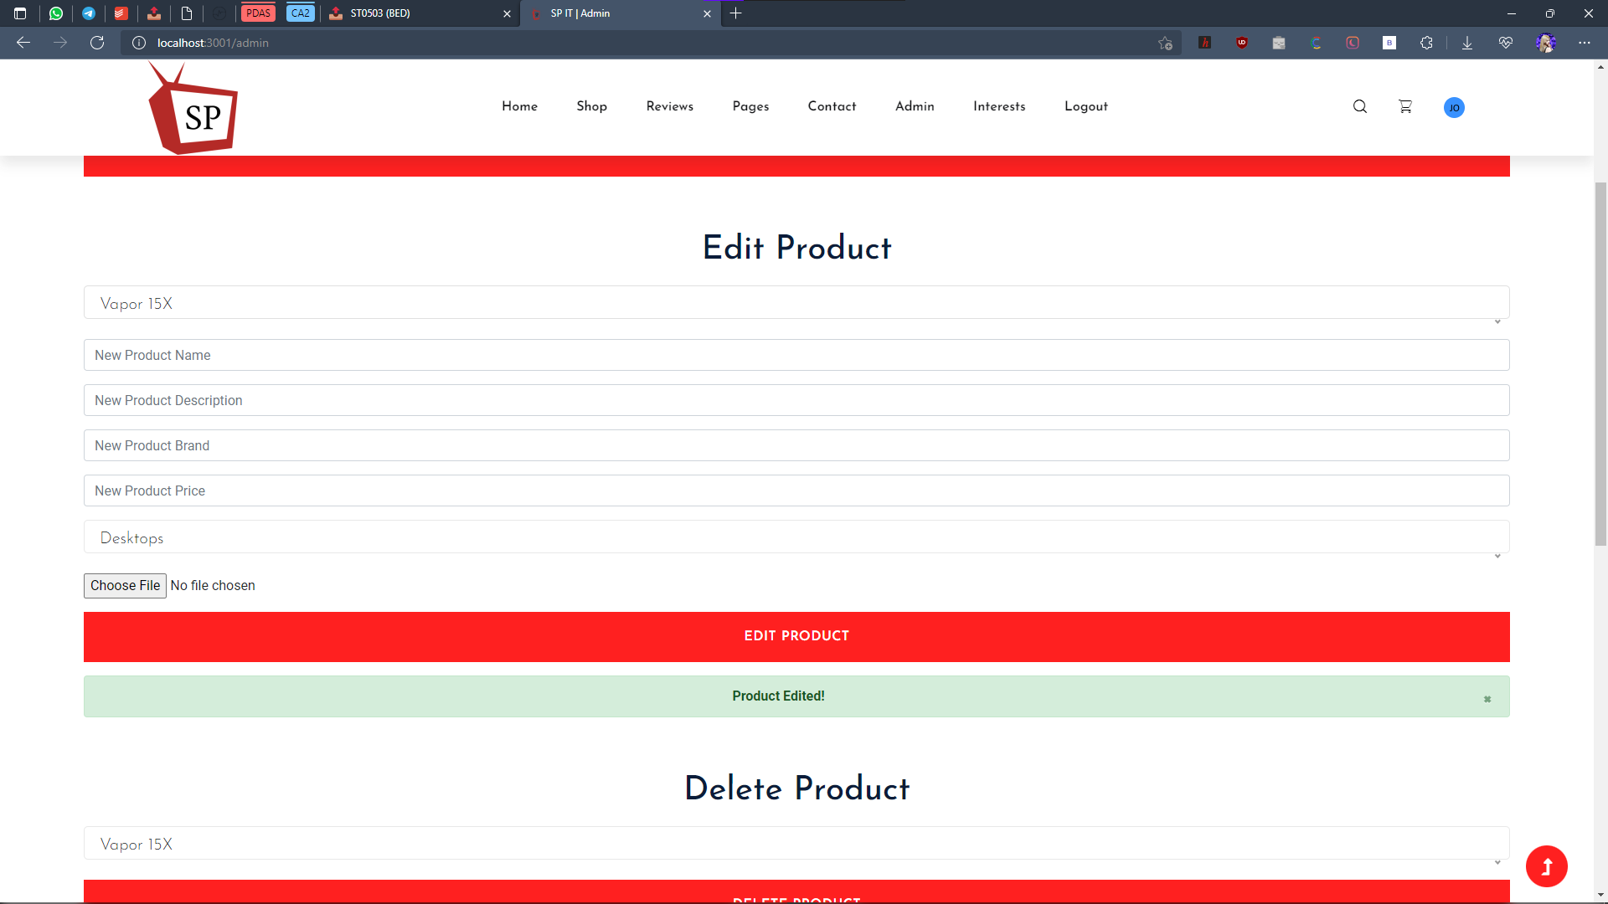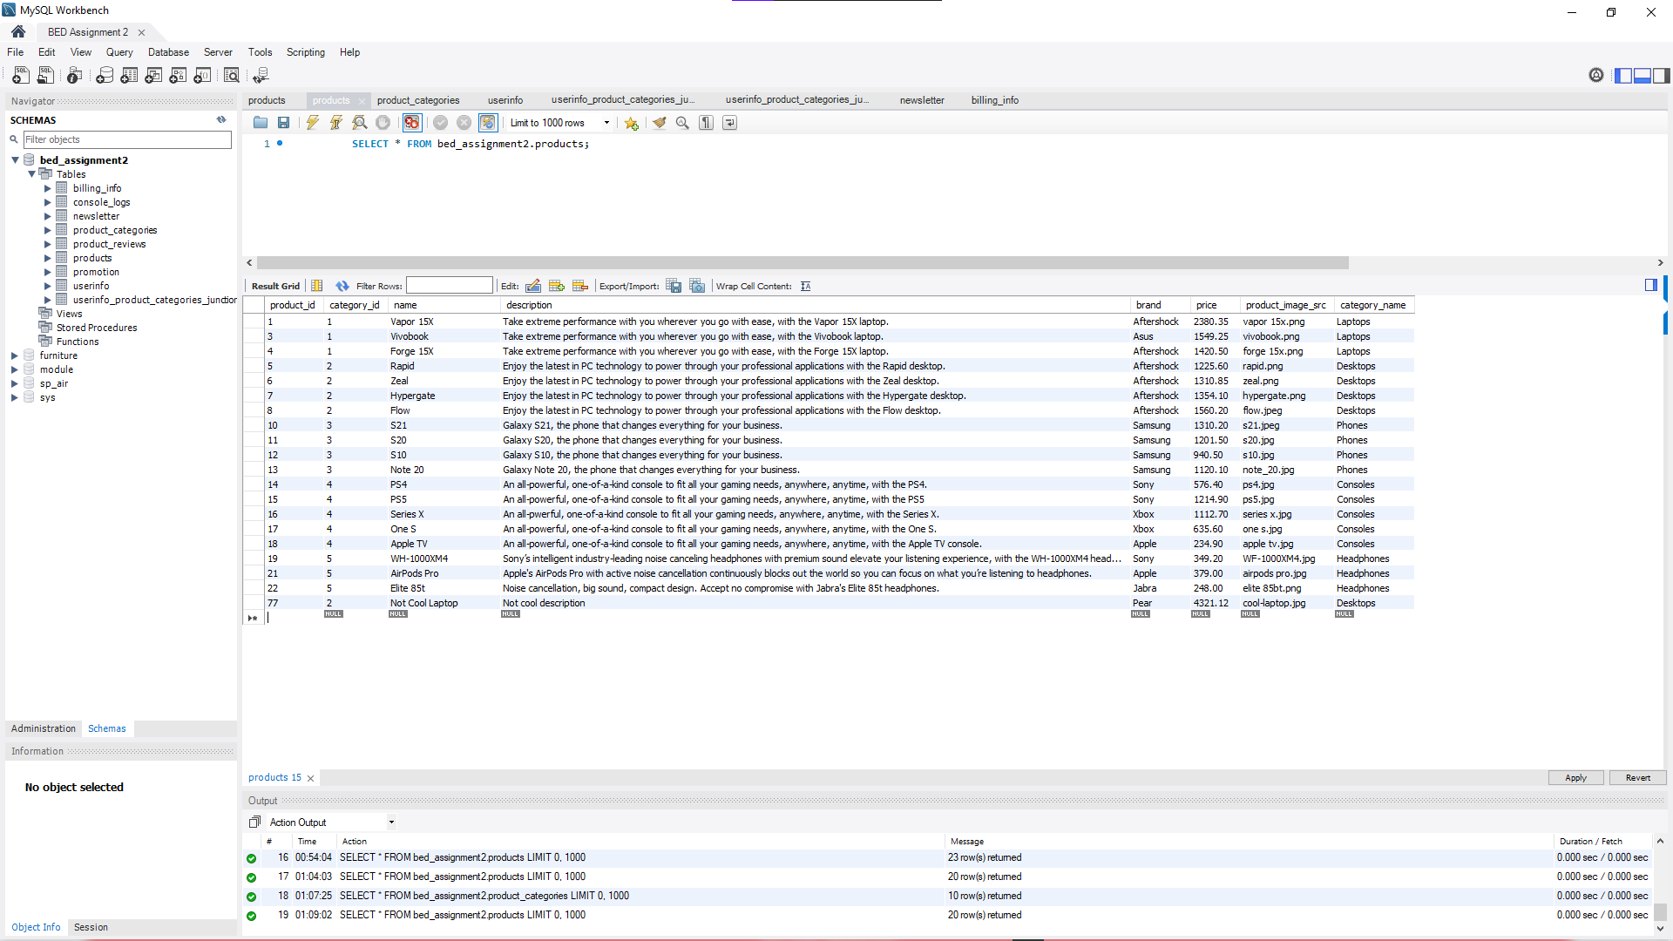

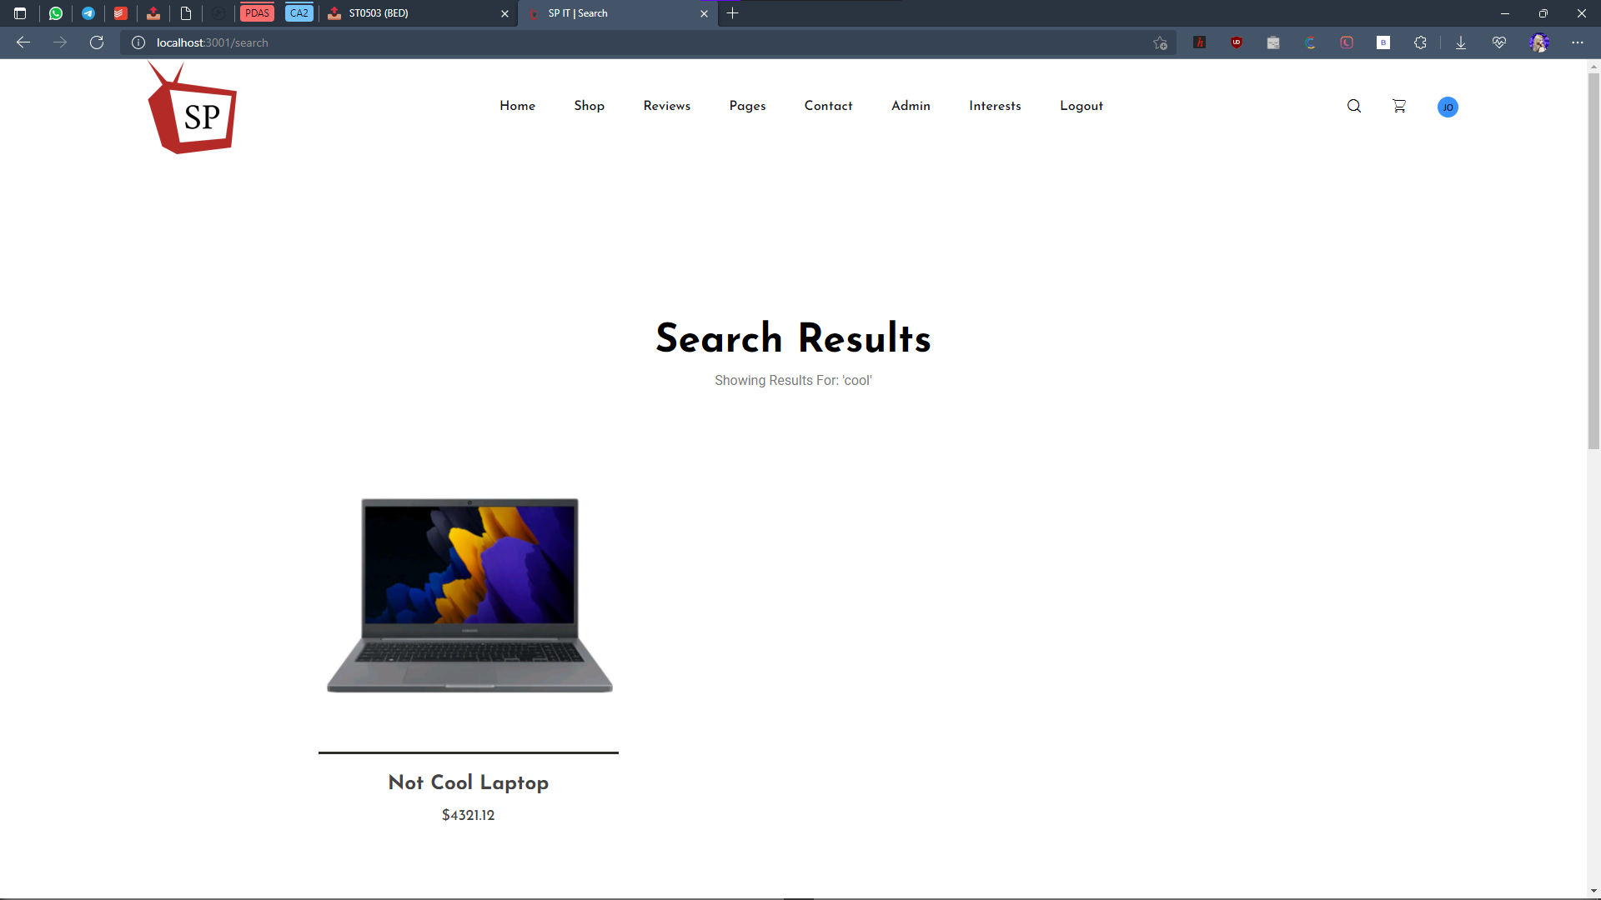

Delete Product

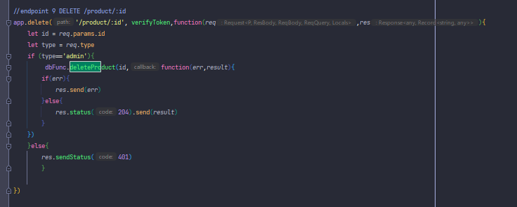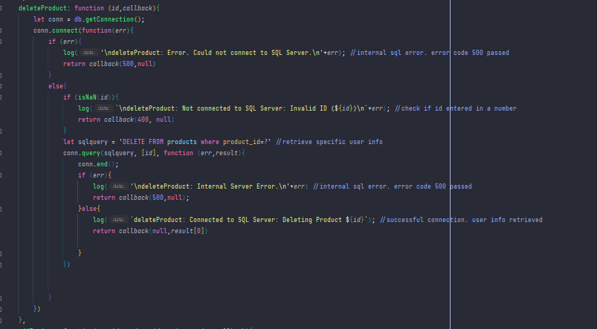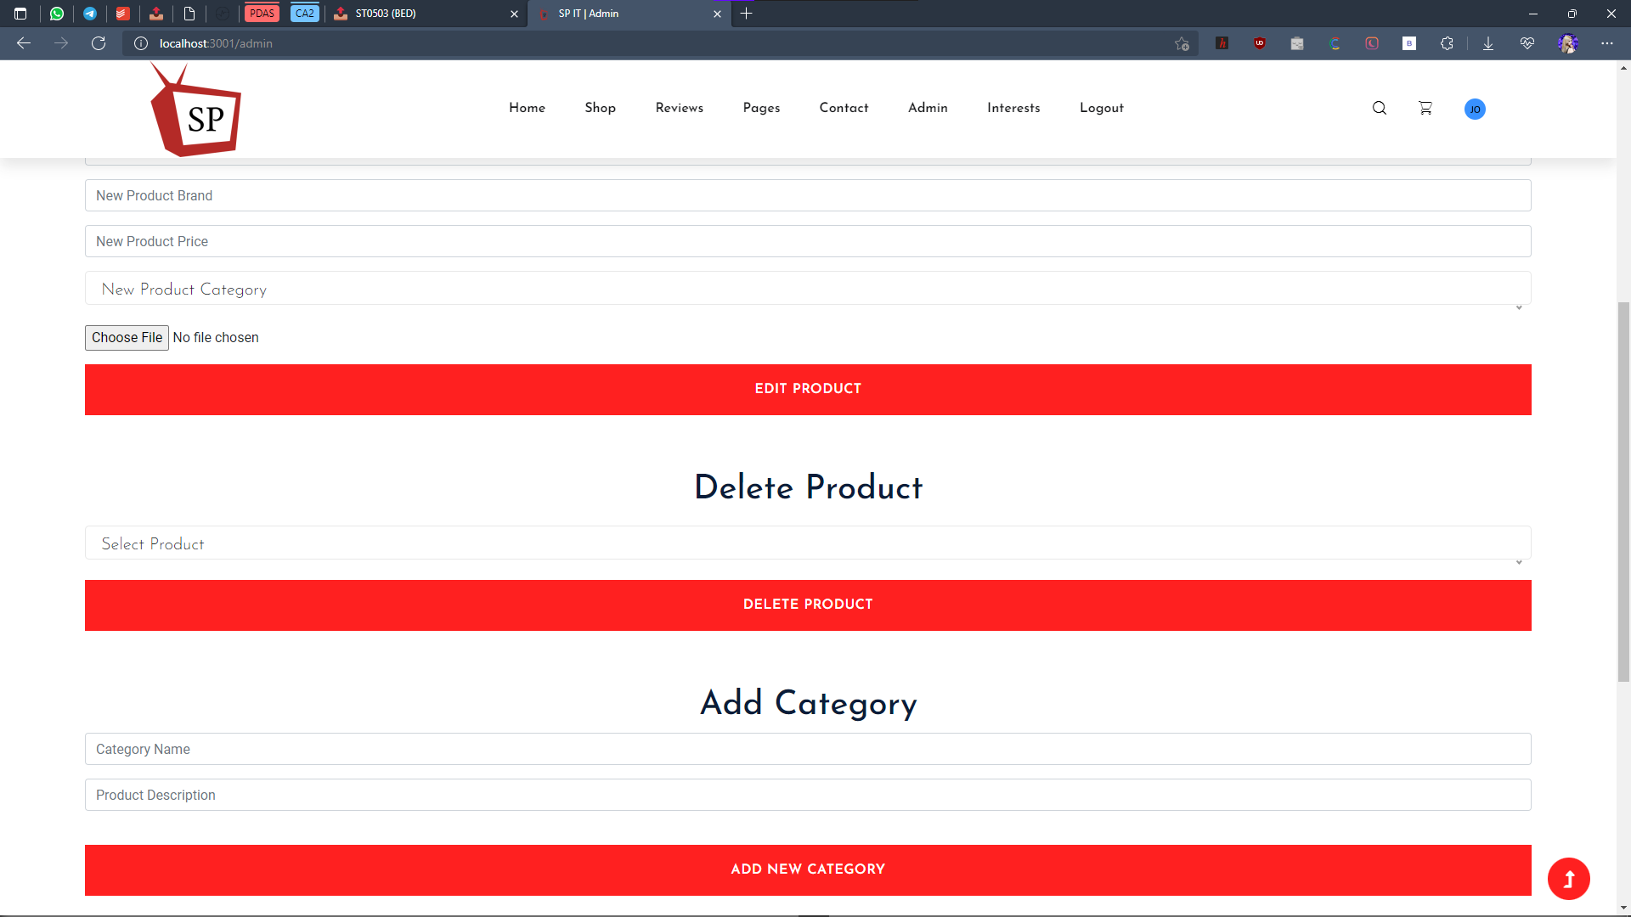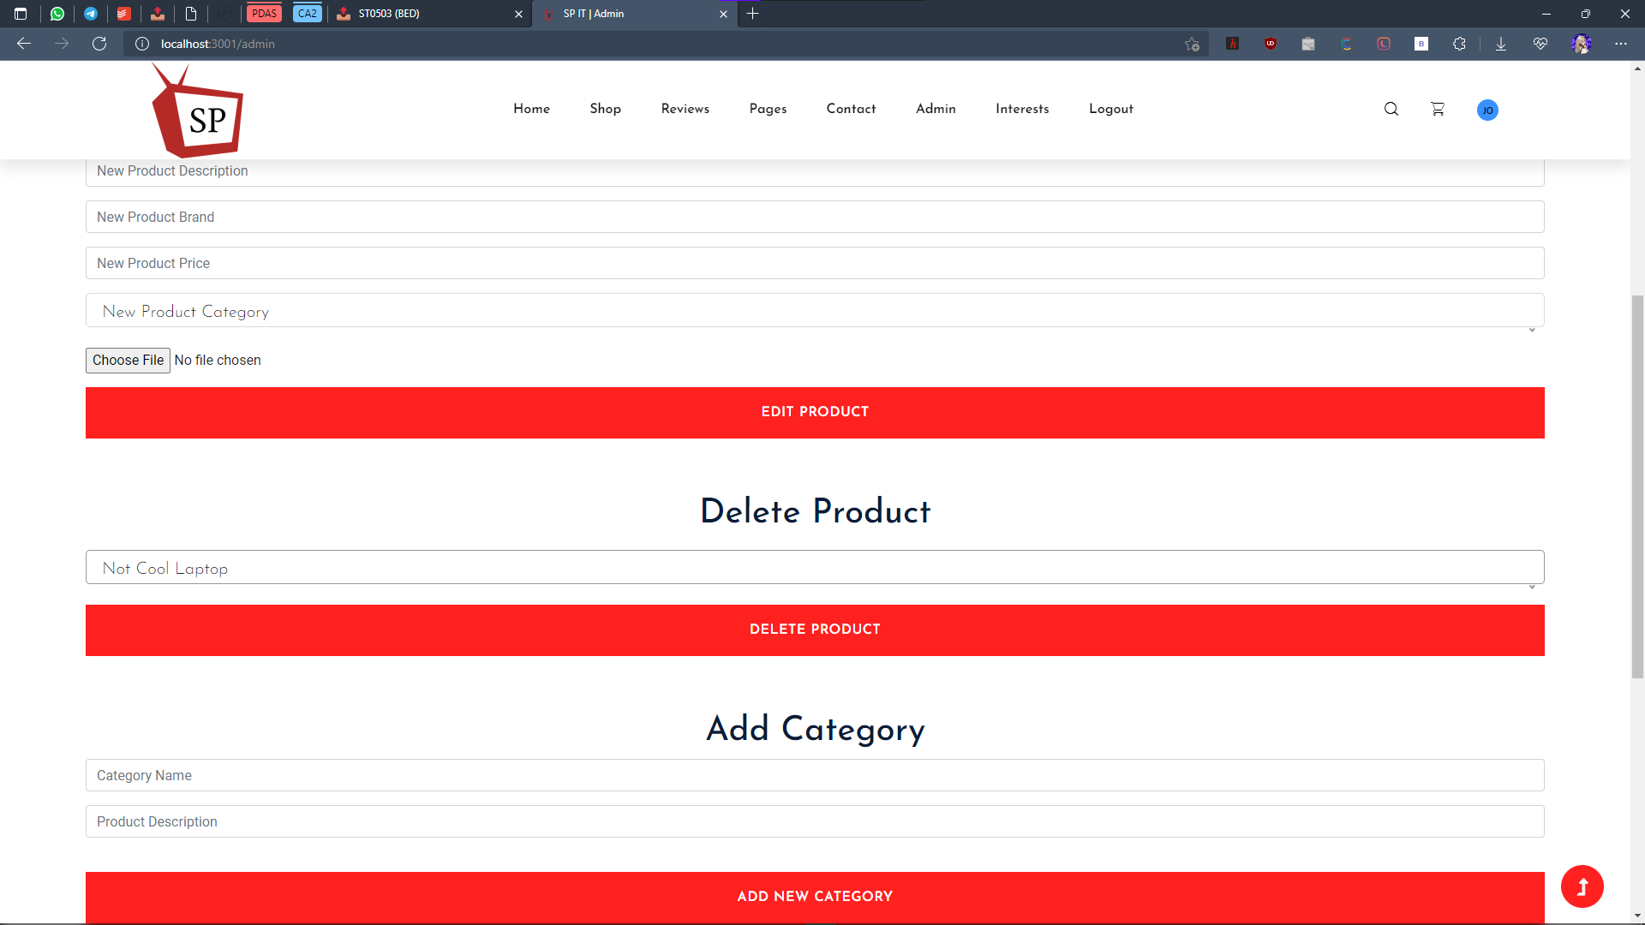

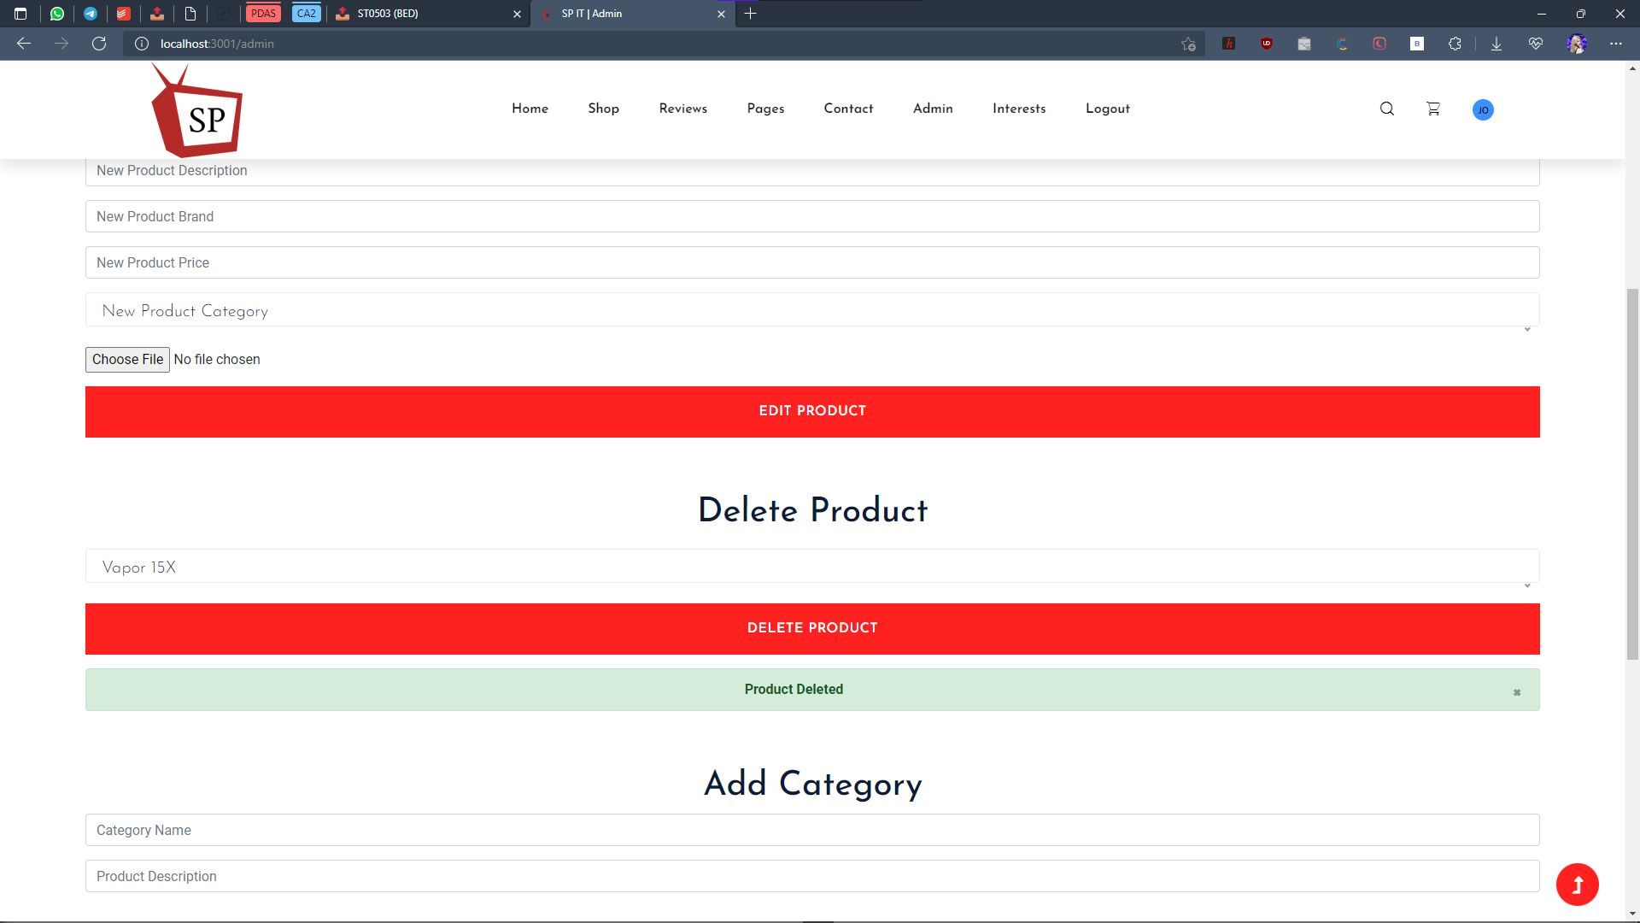

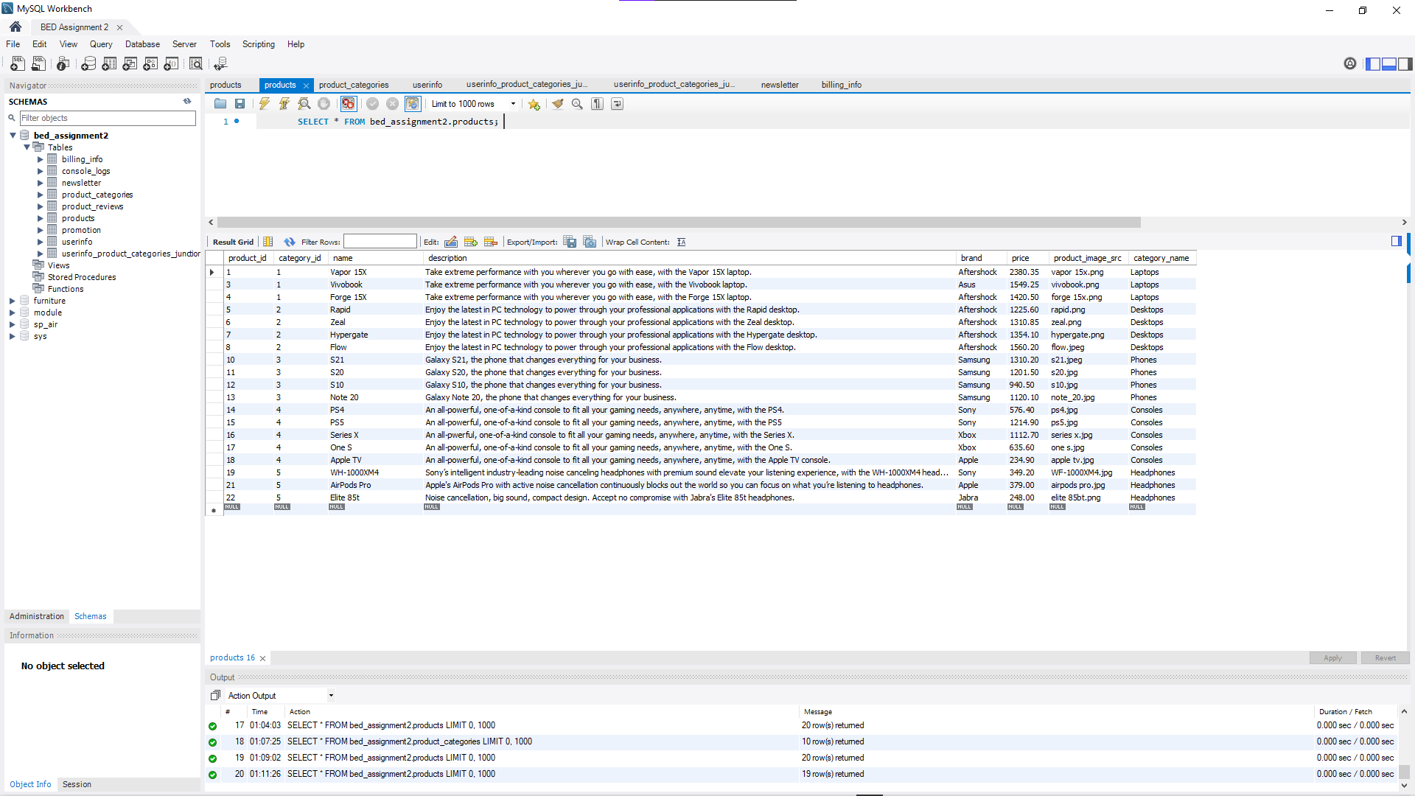

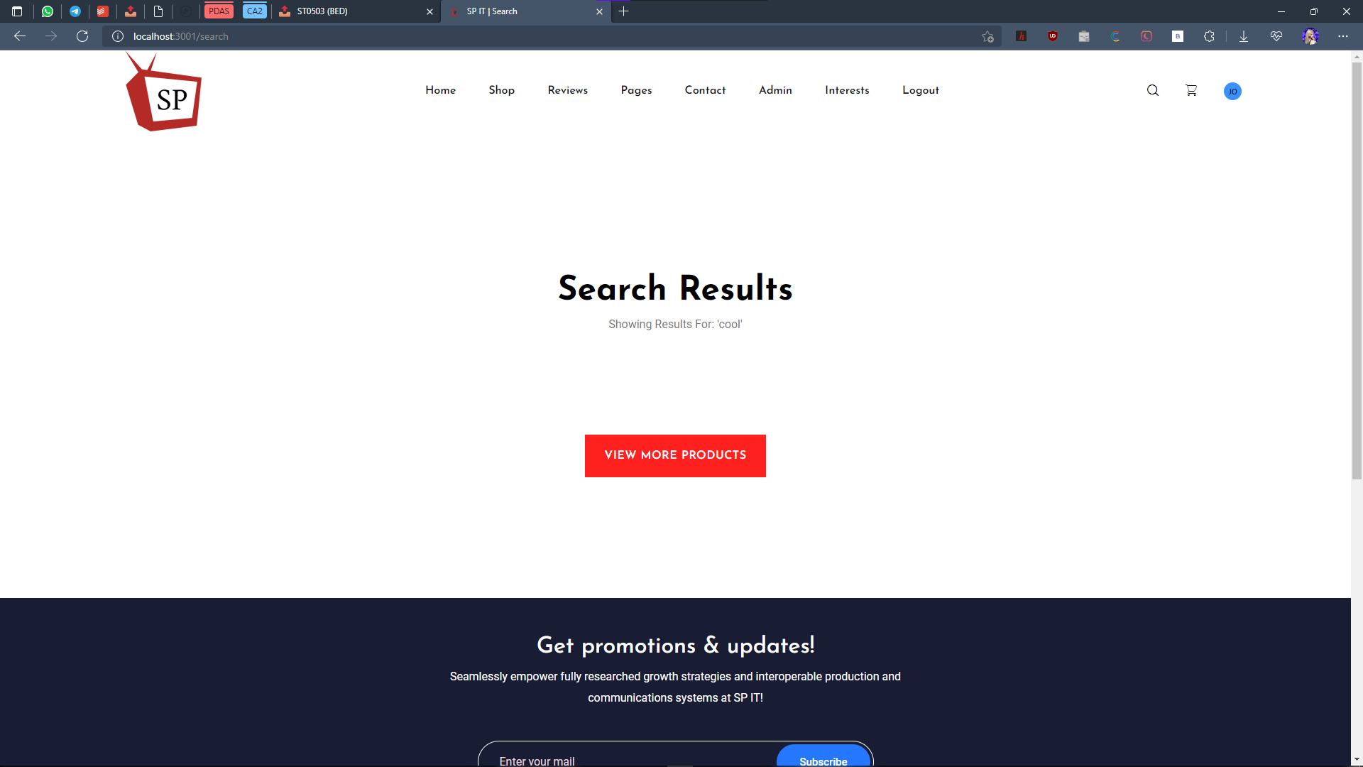

Purchasing products and then confirm payment details and check out with data saved to database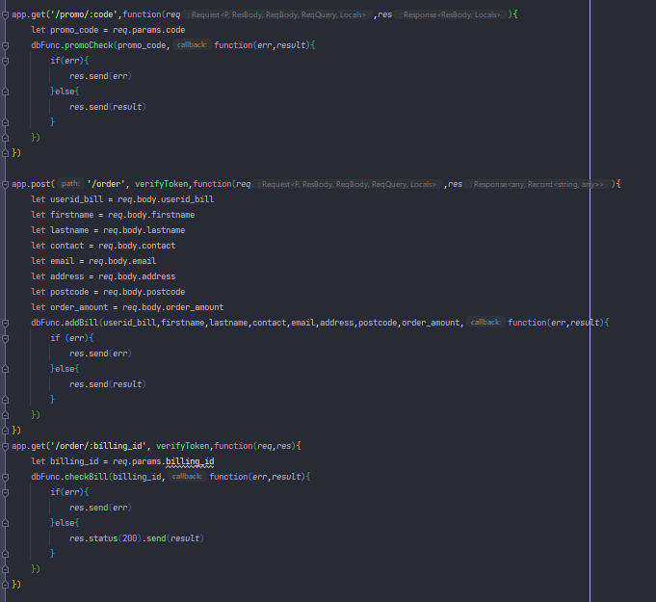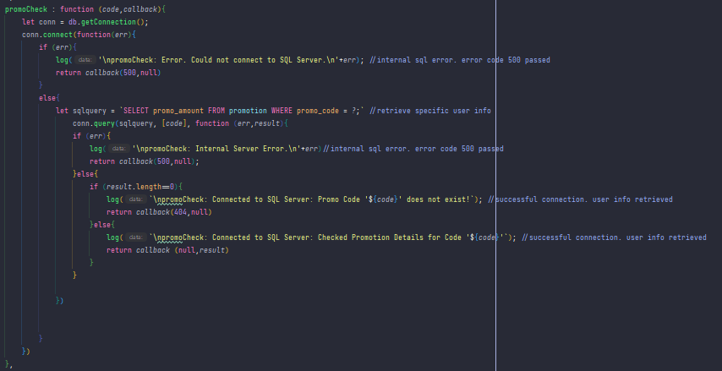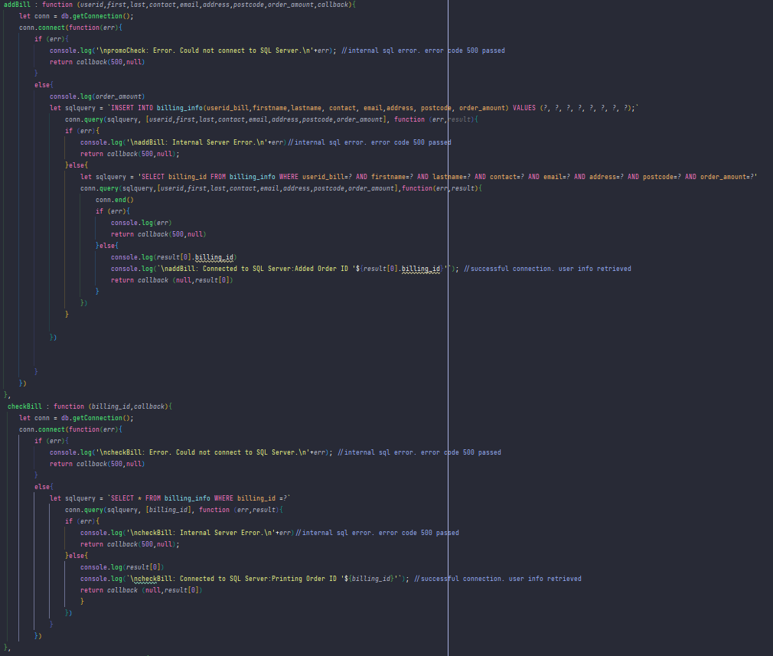

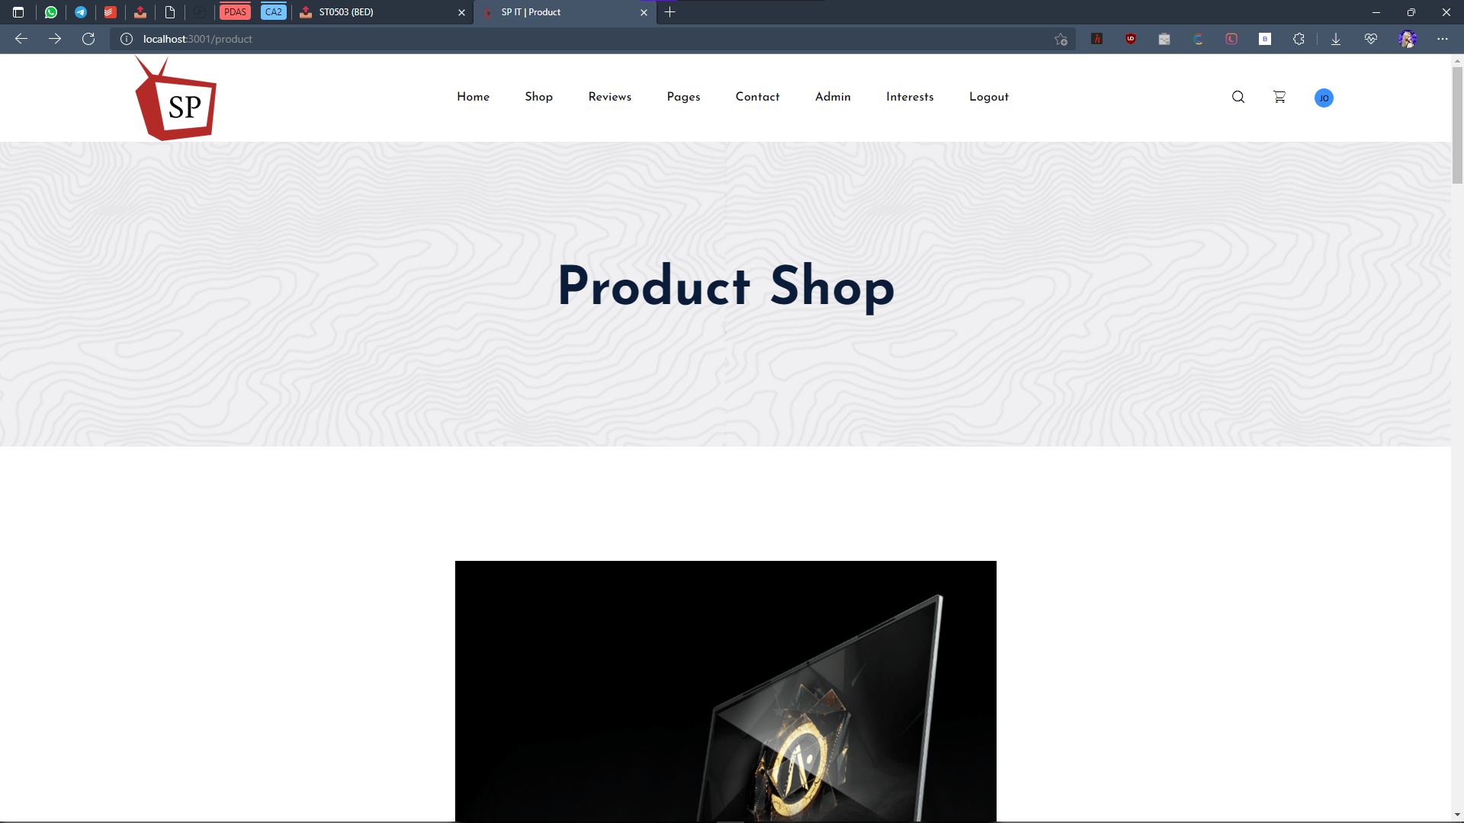

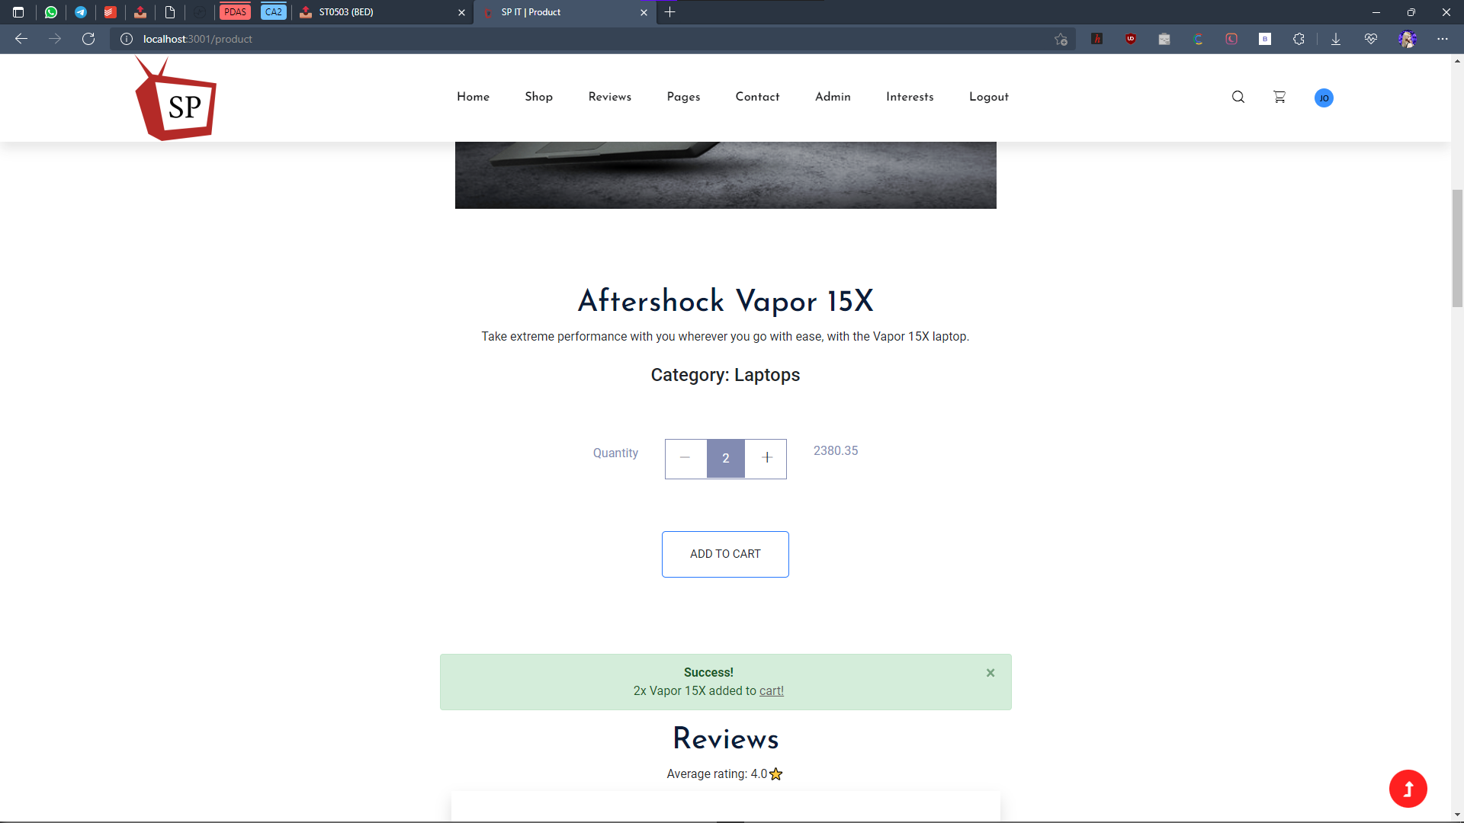

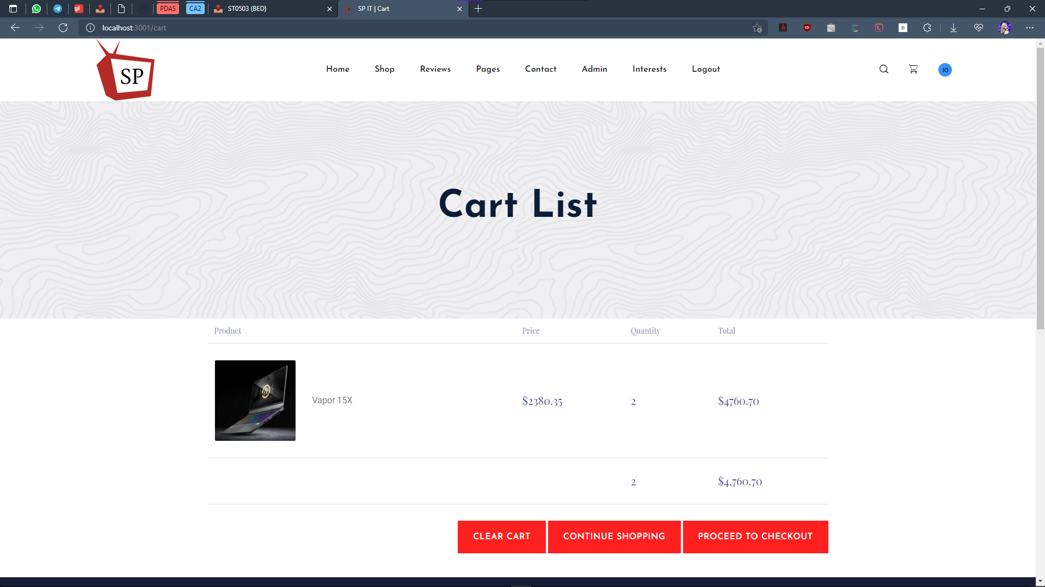

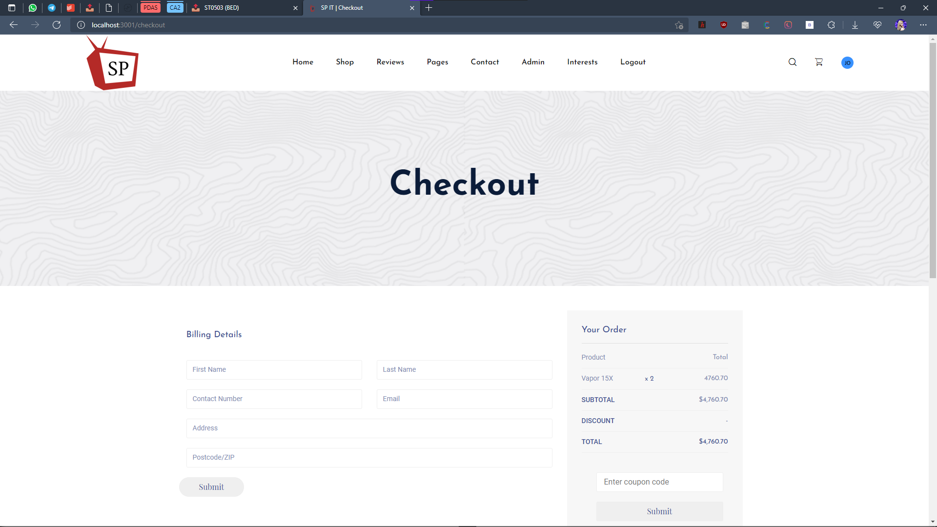

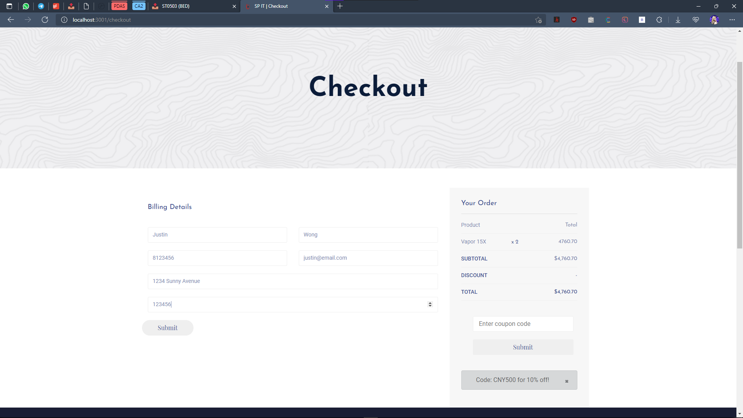

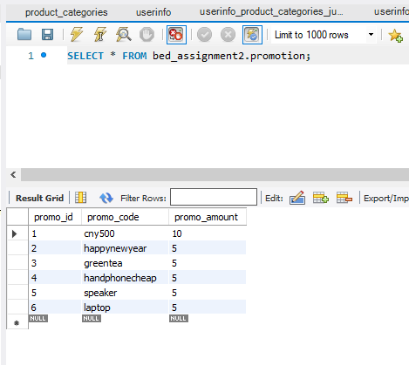

Without Promotion

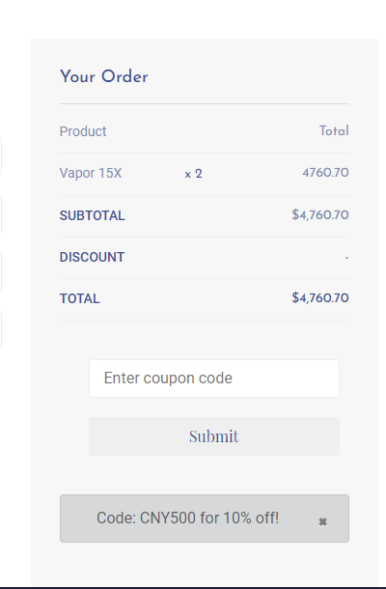

After Promotion (cny500)

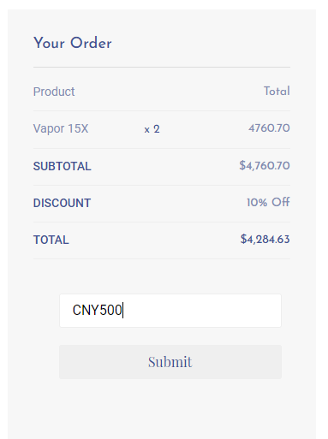

Other promotion code (greentea)

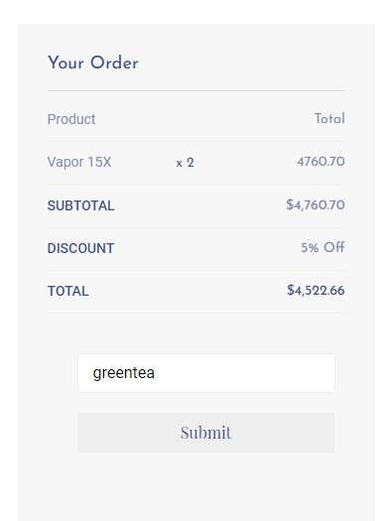

Using invalid promotion code:

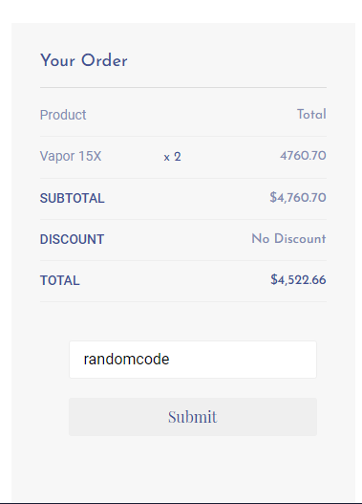

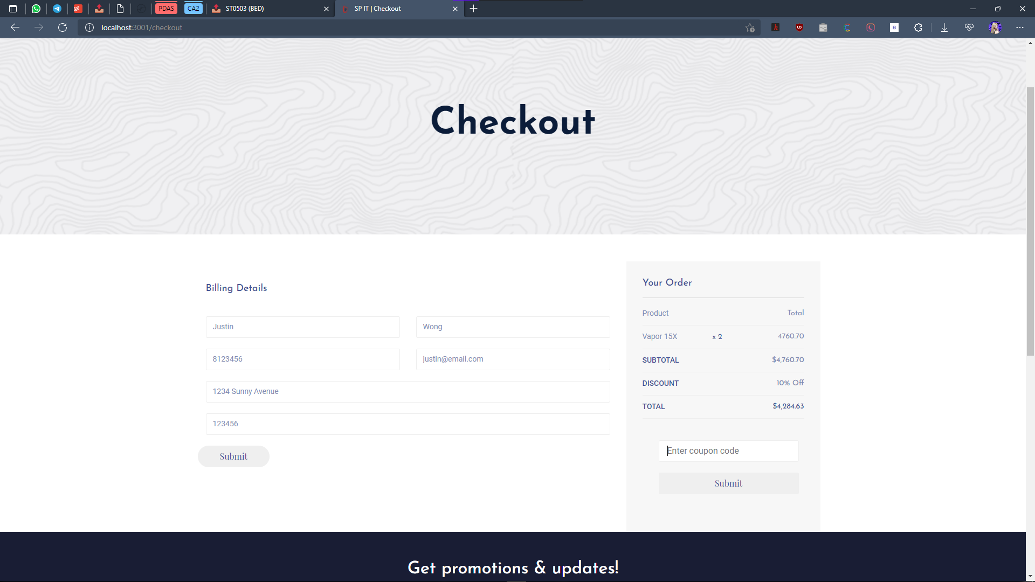

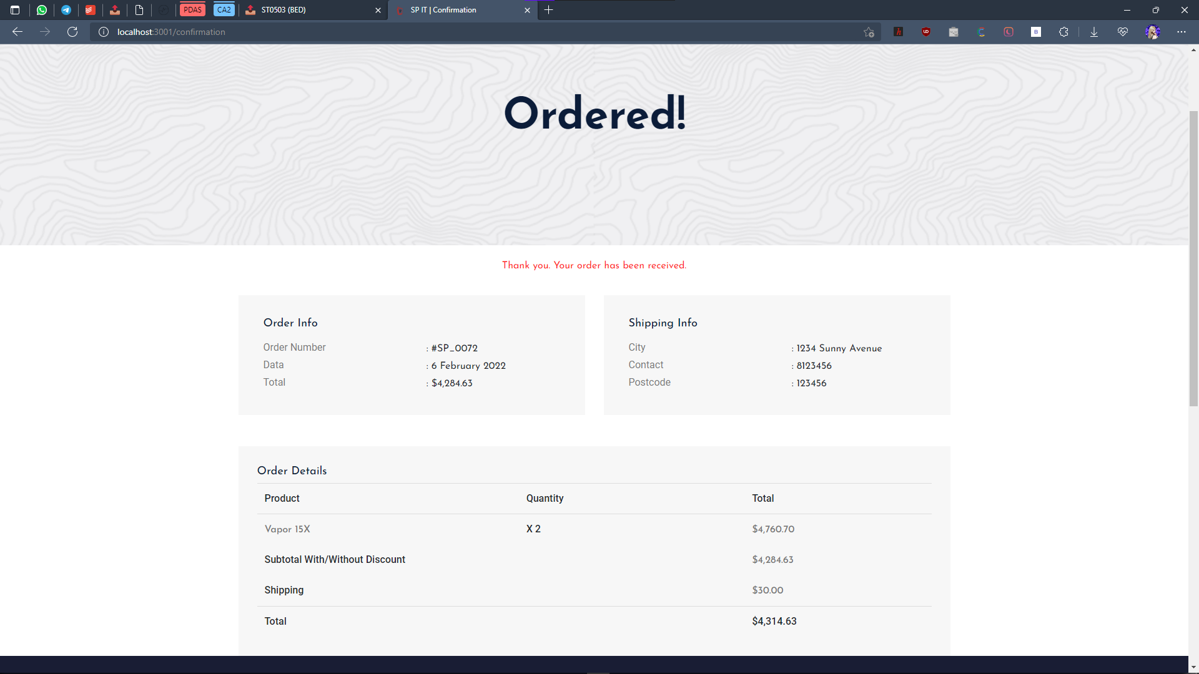

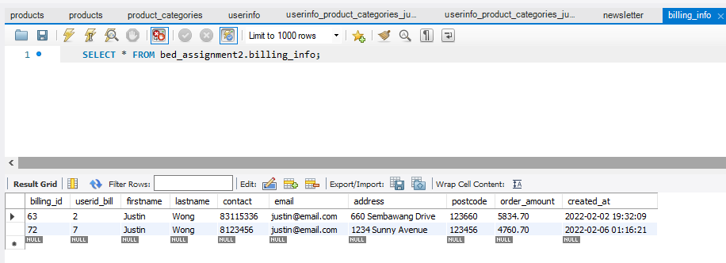

Add Category

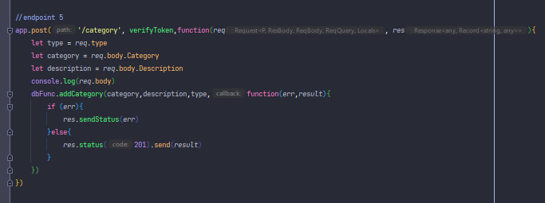

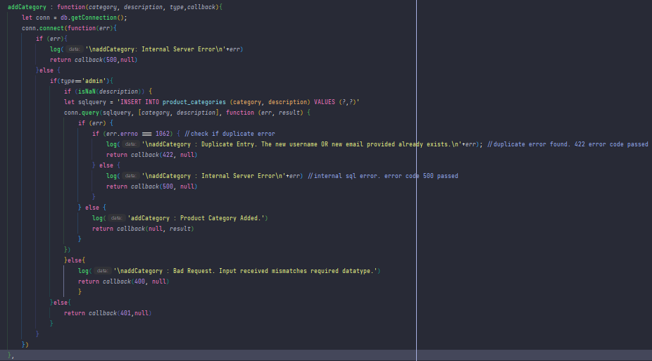

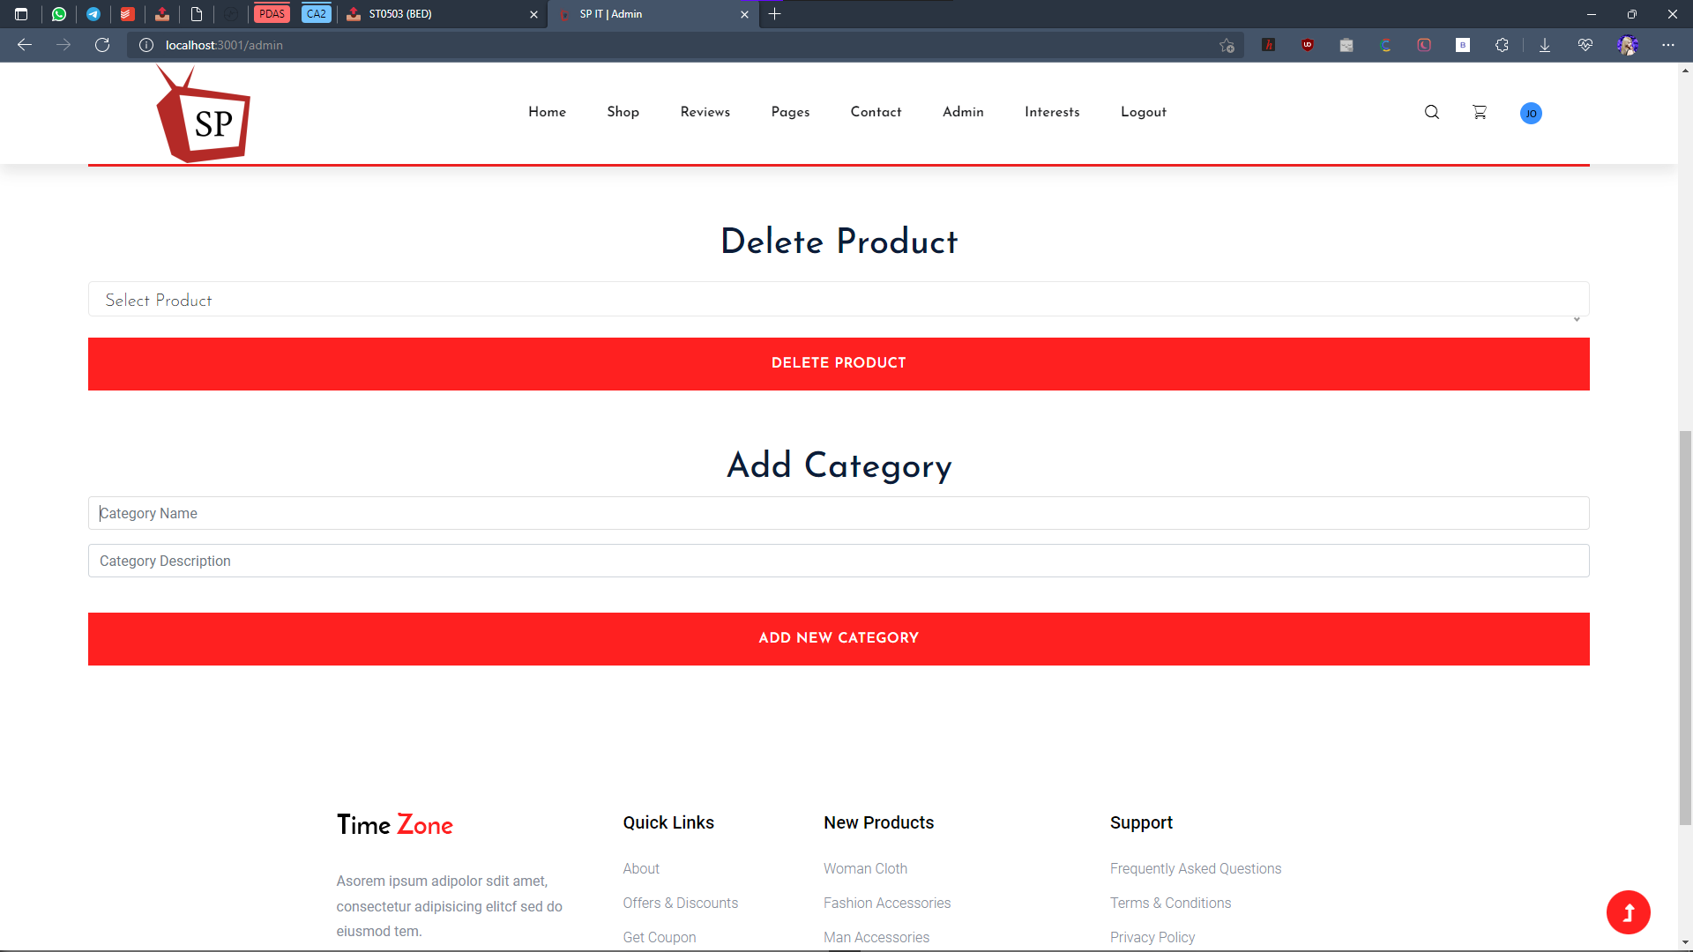

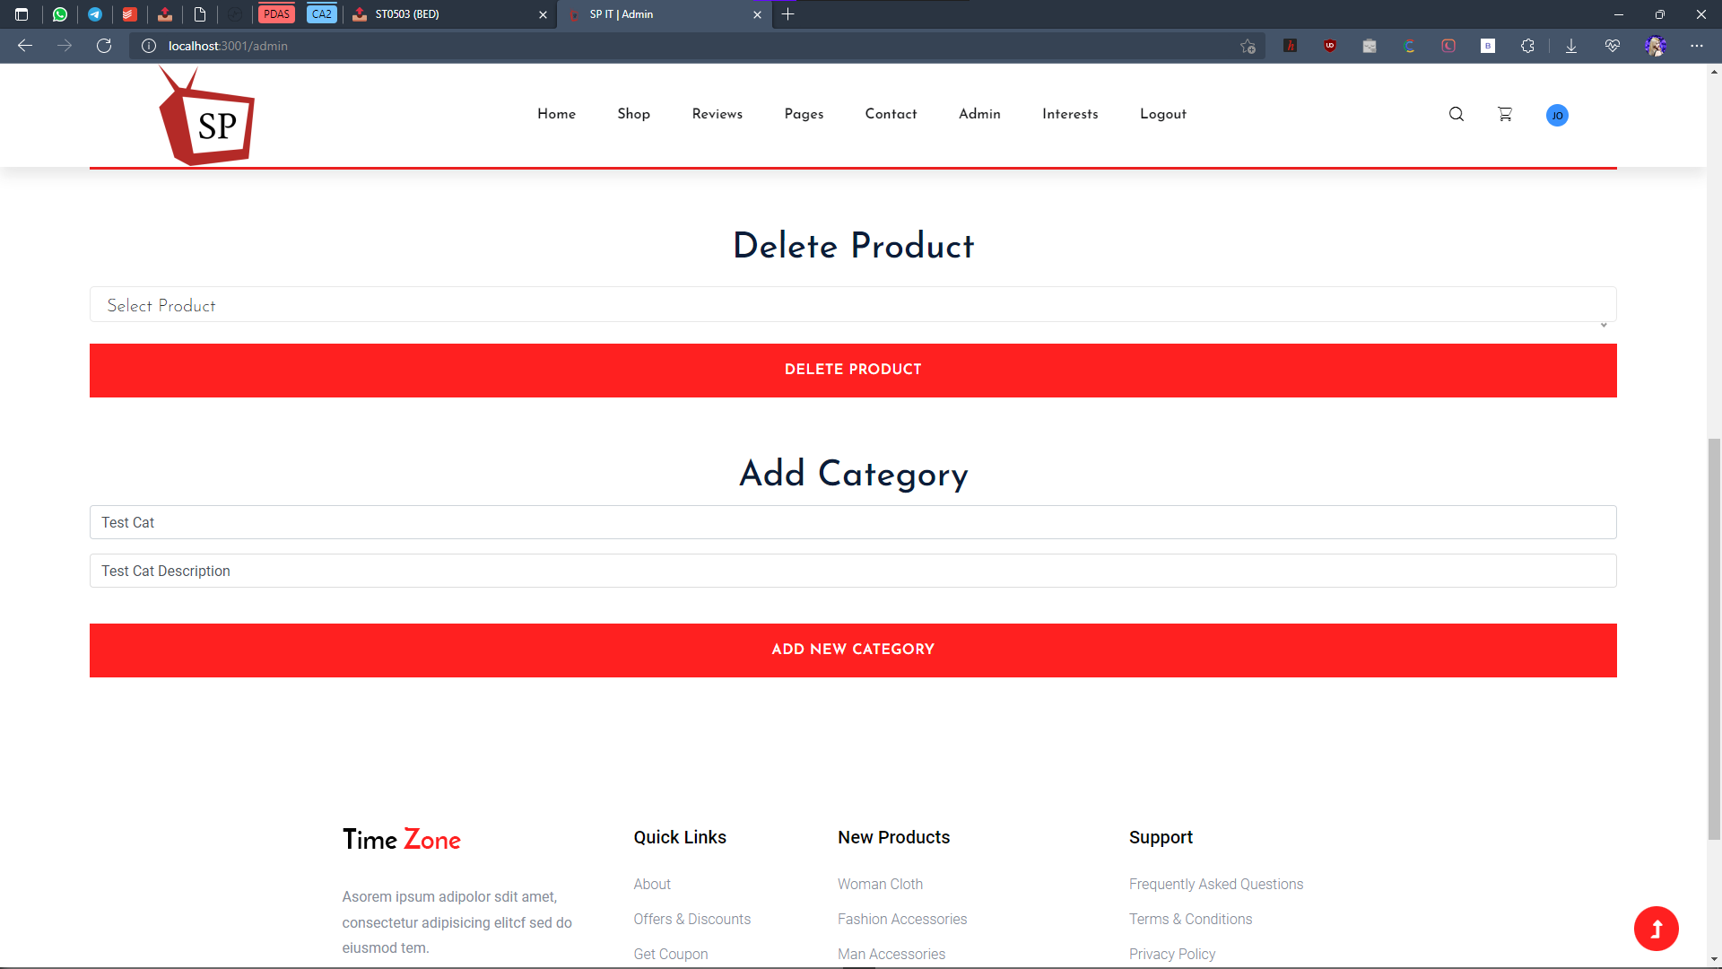

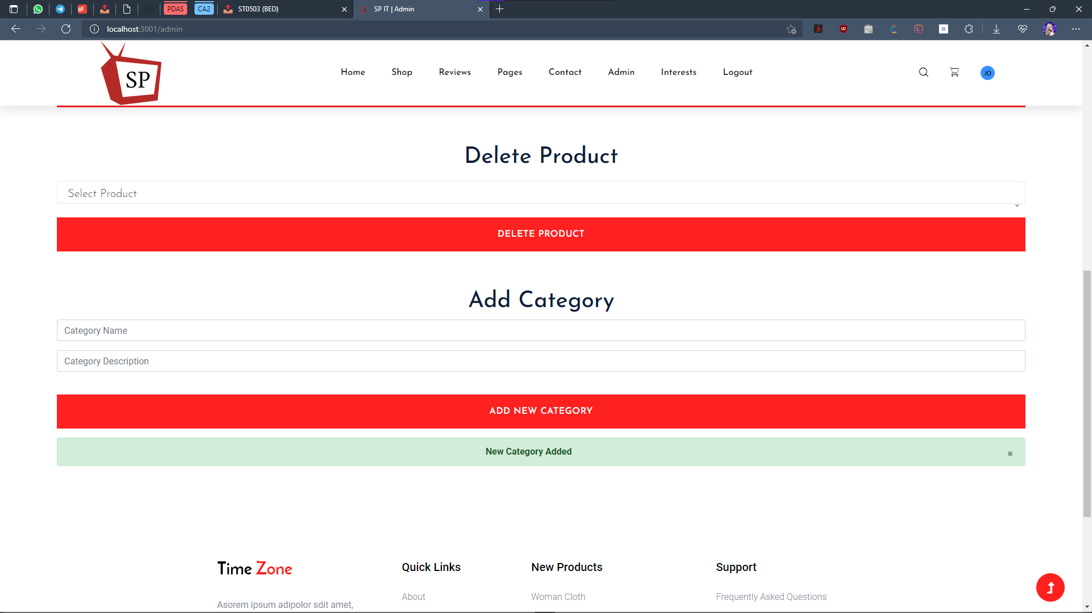

Change reflected in category interests:

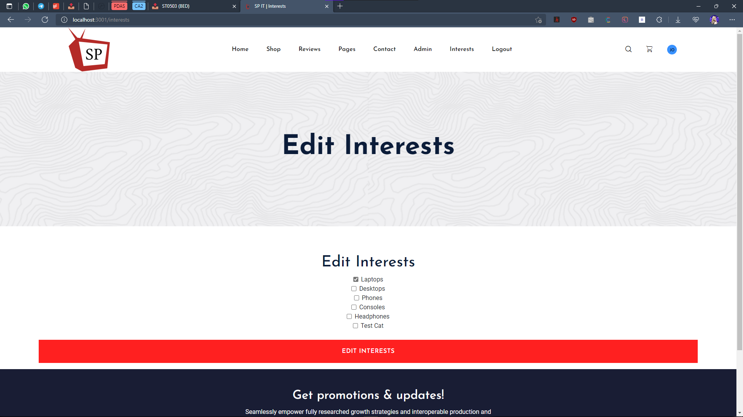

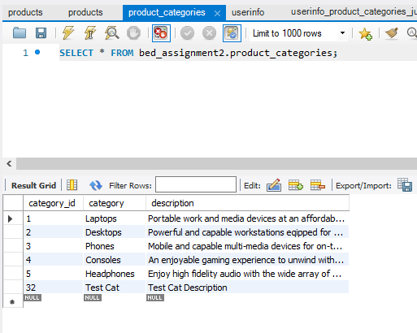

Sign up for newsletter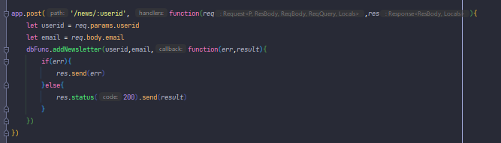

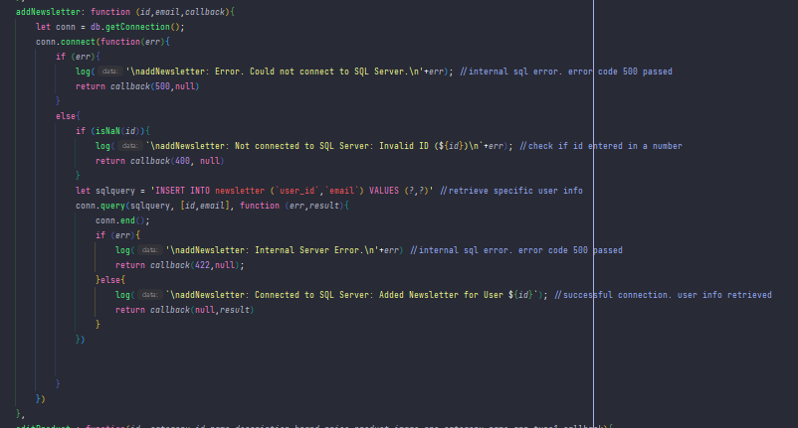

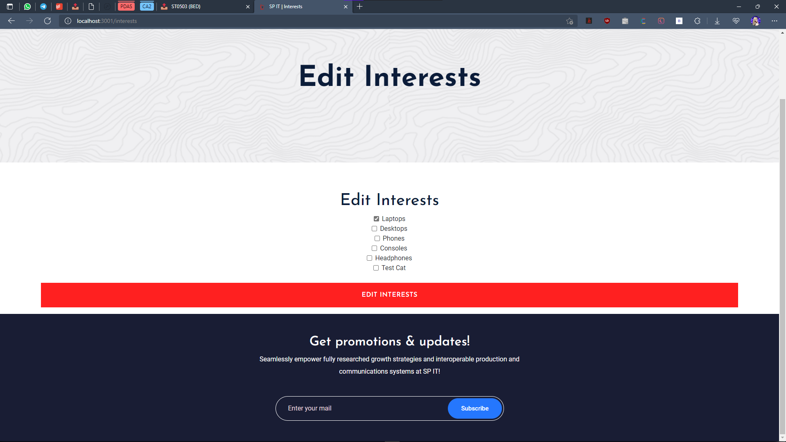

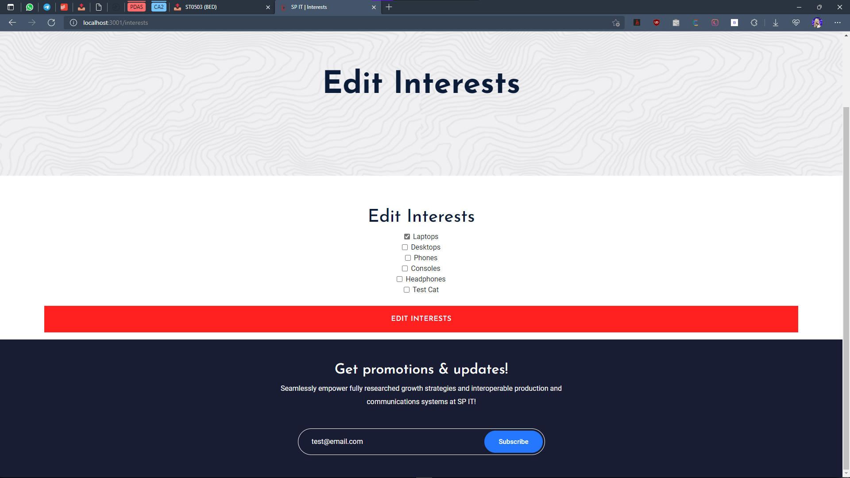

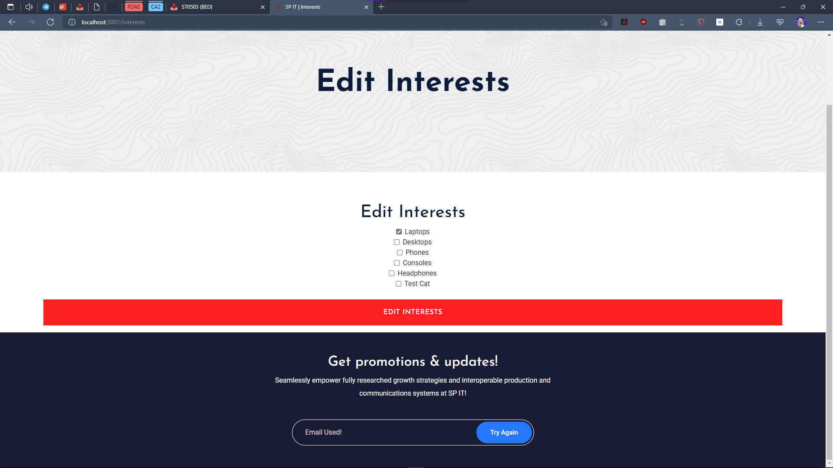

Duplicate checking enabled ^^

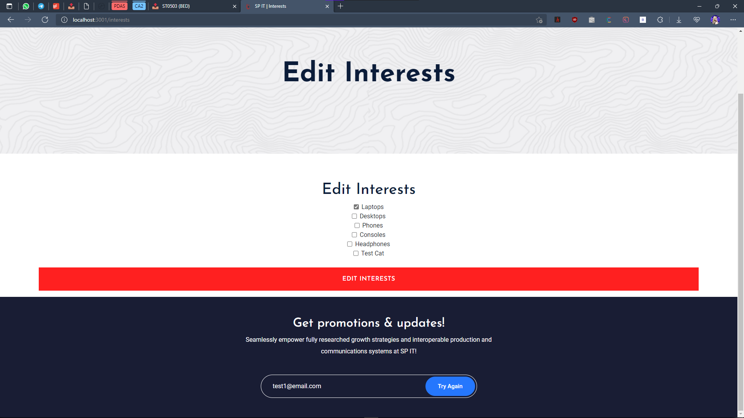

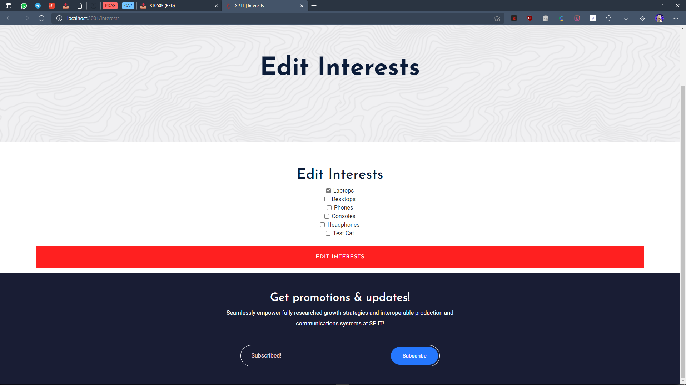

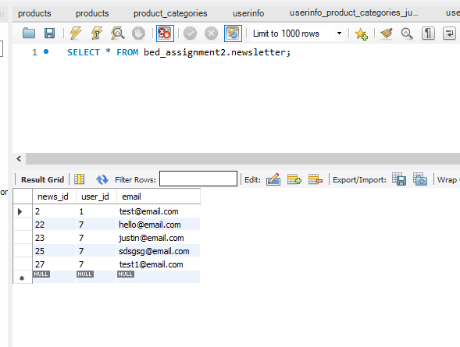

Verify Token

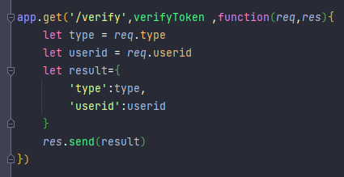

Check Category

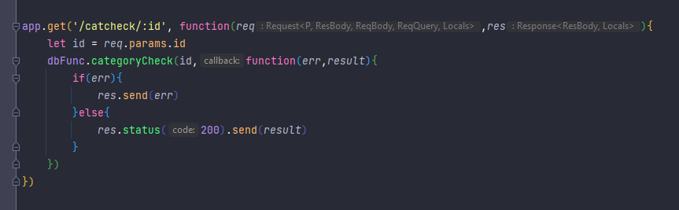

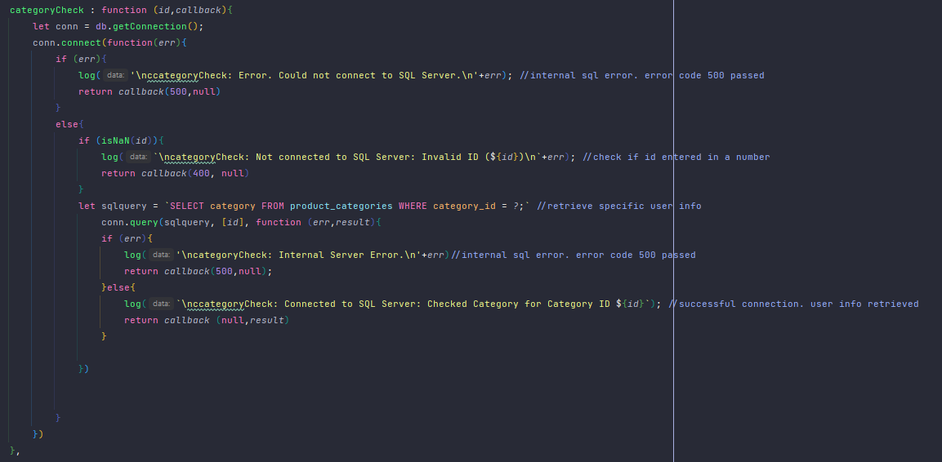

User login

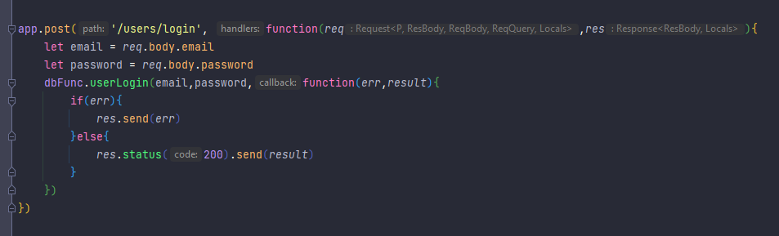

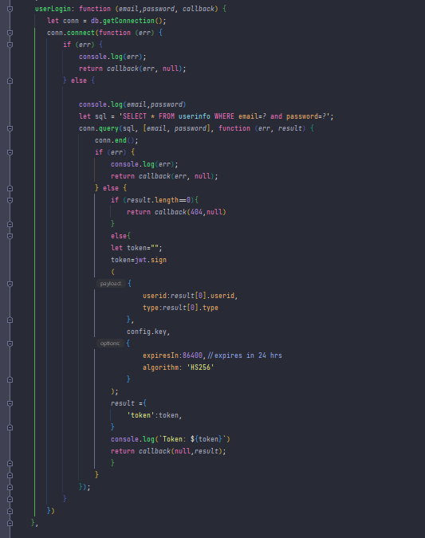

Delete Product

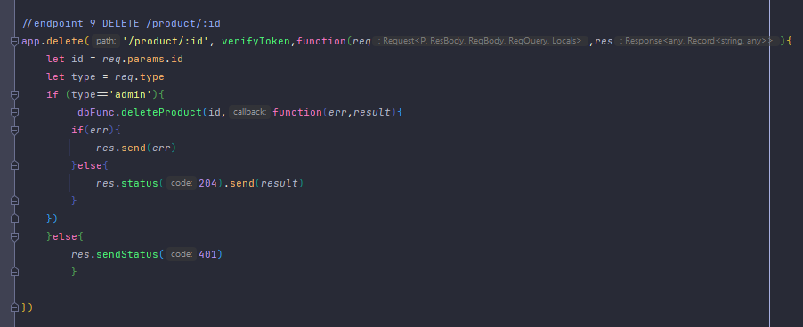

Add new review

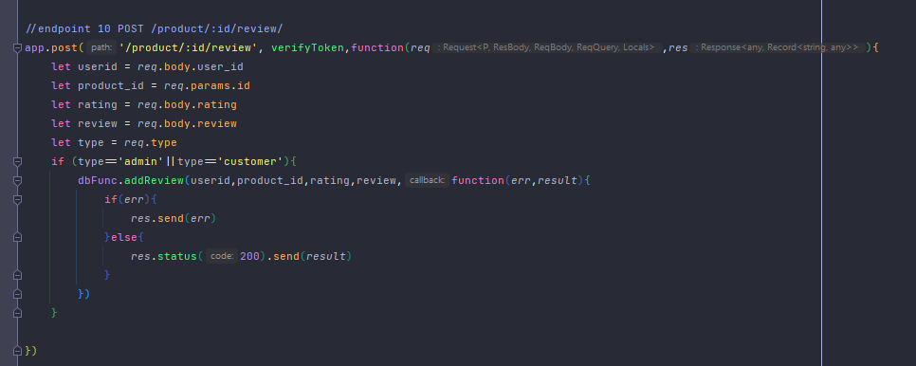

Get specific review

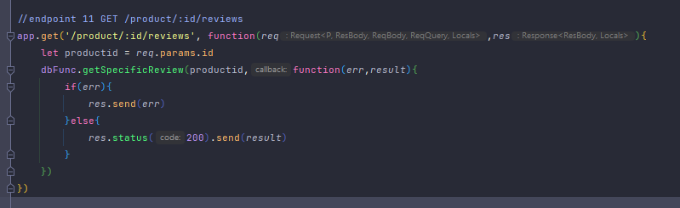

Add user interest

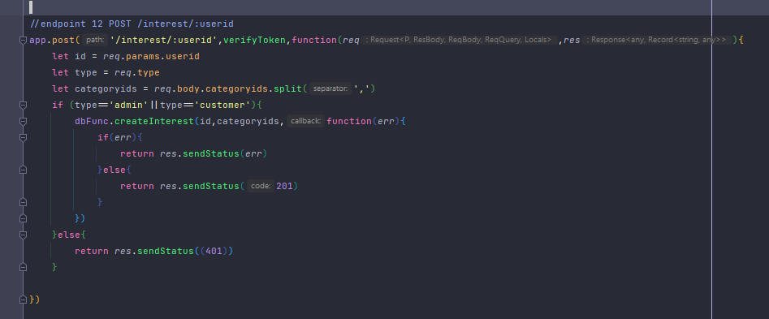

Get specific user interest

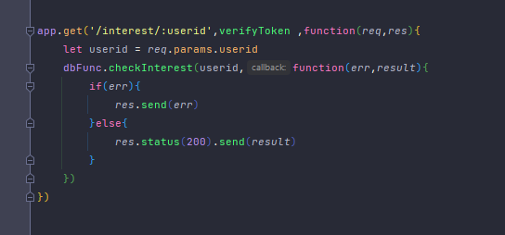

Get all products

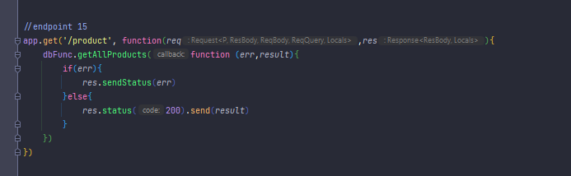

Get all products within `gory

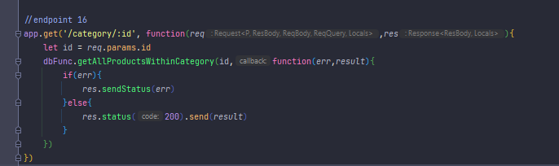

Get all reviews

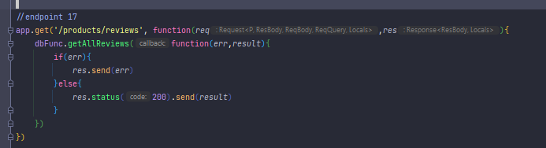

Search function

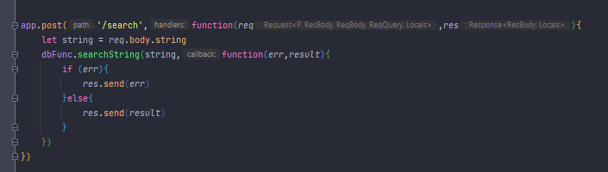

Add new user

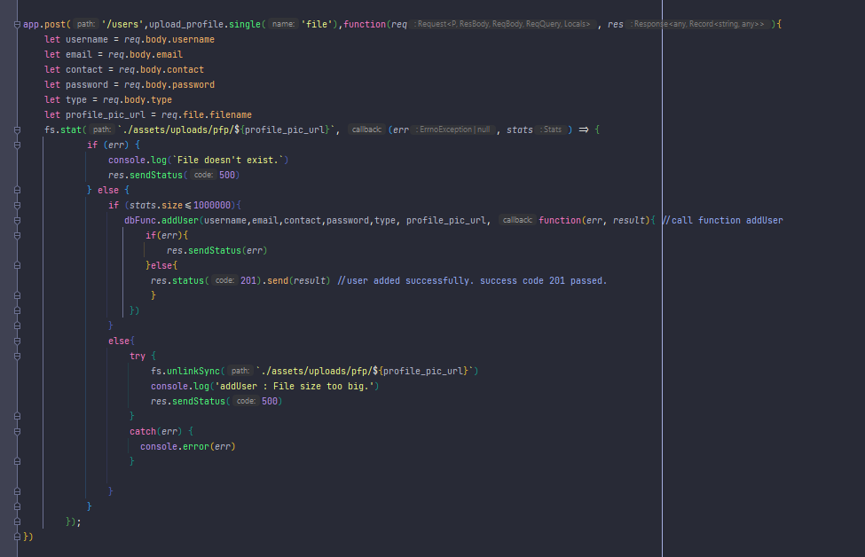

Get all users

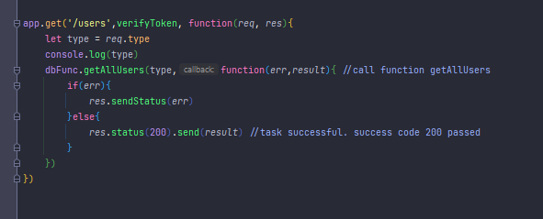

Get specific user

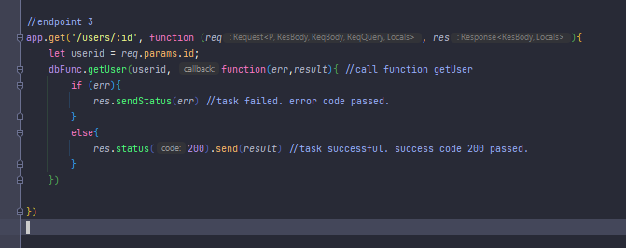

Edit user

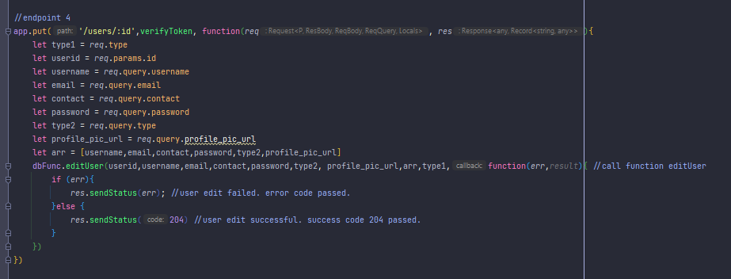

Get all categories

